NH Coastal Viewer Training: Saving and Sharing Projects

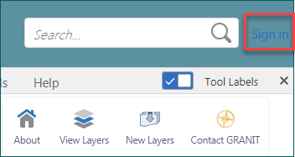
- Sign in to ArcGIS Online
  - After you Sign In to ArcGIS Online, you can save the maps you make as a Project or open Projects created by other ArcGIS Online users in your community
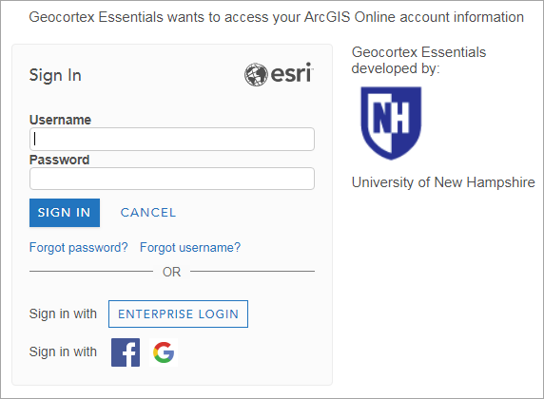
  - When you Sign In, the Coastal Viewer will refresh and you will lose any work you have done on your map
  - To Sign In, click the link in the upper right corner, and enter your ArcGIS Online User Name and Password
  - If you do not have a User Name and Password, go to https://www.arcgis.com/home/signin.html to create a free ArcGIS Online account.

- Save your work as a Project
  - You can save your map as a Project
  - You must be signed in to ArcGIS online to save a Project
  - Click the Save button in the toolbar
  - Type a Name and Description for your Project; click Save
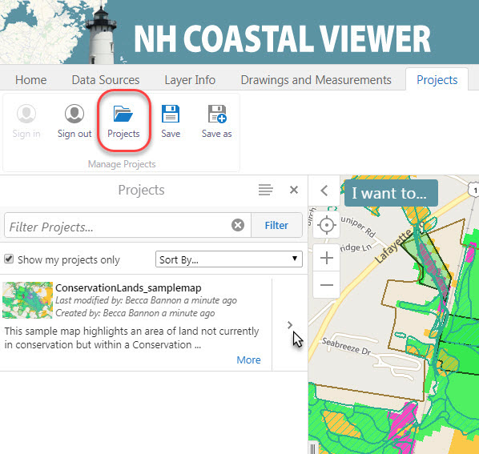
  - To share your project with others, click Projects
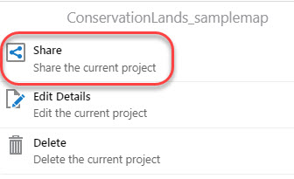
  - Your Projects List will show any projects you have created or that have been shared with you (turn off “Show my projects only”)
  - Click the arrow next to the project name, then click Share

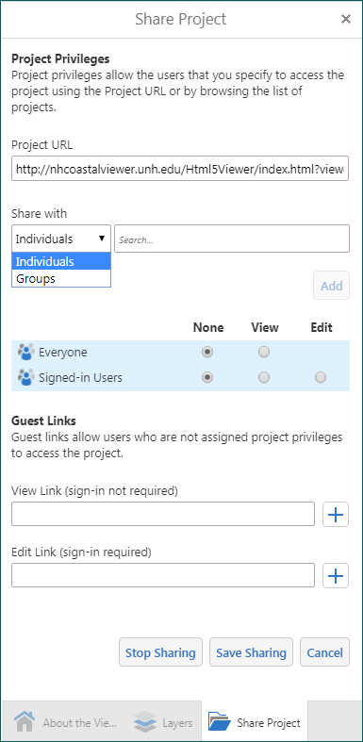
  - You can provide members of your organization, or groups to which you belong, access to your project by assigning Project Privileges
  - Type a name in the Search box to select an individual or group name
  - Select View or Edit privileges for the public and your designated users
  - Designated users will be able to access the project from their Projects List or by using the Project URL
  - To provide access to your project to people outside your organization, you can choose to send a Guest Link to View or Edit the project
  - Click the plus sign to obtain a link that you can send to anyone you choose. Keep in mind, this link will allow either View or Edit privileges to anyone who receives it
  - To save your project sharing settings, click Save Sharing
  - To eliminate access to your project, click Stop Sharing.

Apply your skills:
1. Save a map project with at least one data layer turned on. Close out of the Viewer session. Open a new Viewer session and open the project you saved.
2. Save a map project and share it with the person sitting next to you by emailing them a project guest link with edit privileges. Ask them to make and save edits to your project. Open your project again. Can you see their edits? If you don’t have access to email, you can share the guest link with someone after the training.

