Farmington NH/Cocheco River Levee - Conference Call Summary
May 15, 2017
Alex Sirotek, John Grace, Jeff Burm, Jennifer Gilbert, Chris Phaneuf, Fay Rubin

Background:
- Constructed by USACE, then turned over to town for maintenance.
- Alex found inspection report from 2000 that indicates it is acceptable.
- Shows on 2005 FIRM as providing protection, but no reference on panel or in FIS. Also had implied protection on older 1988 and 1976 FIRMs

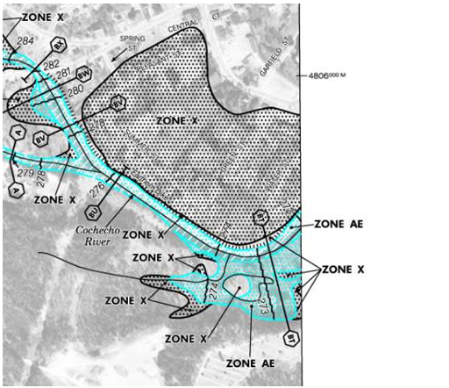

- August 27, 2013 – flagged by USACE as unacceptable during inspection, e.g. having deficiencies and needing repairs

Current Discussion:
- Need to determine its status due to 2013 USACE report. From FEMA’s perspective, levee is still accredited.
- Official procedure – initiate a LAMP assessment process to determine if it provides any protection. Can be 1-2 year long process.
- For our mapping project - it may possibly still provide some protection, so eliminating the entire “X” zone is not appropriate. Could be shown at least in part as Zone D (indicating there are possible but undetermined flood hazards).

Next Steps:
- John and Kerry (with Alex’ input) to determine if they want to fund a LAMP project. If so, what is the contracting mechanism? Alternatively, can be accredited through LOMR process.
- Contact USACE to collect any additional information
- Contact town of Farmington to see what their plans are re repairs, etc.
- Consider community outreach given number of structures/homes that could be impacted (see below).

