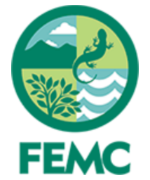
Society for the Protection of New Hampshire Forests Aerial Imagery 1953-1995

Contact Information
Society for the Protection of New Hampshire Forests
Gabe Roxby, Field Forester
groxby@forestsociety.org
603 224-9945 x 357

Forest Ecosystem Monitoring Cooperative
Matthias Sirch, Data Specialist
msirch@uvm.edu
802 777-6712

Overview
The Society for the Protection of New Hampshire Forests (SPNHF) partnered with the Forest Ecosystem Monitoring Cooperative (FEMC) to scan, archive, and georeference aerial imagery taken of SPNHF properties from 1953–1995. The objective of this project was to create a digital archive of SPNHF georeferenced imagery to note changes in land use over time. This effort was part of FEMC’s broader 2019 regional Data Rescue project (https://www.uvm.edu/femc/data_rescue) to alleviate the risk of losing inaccessible data by engaging with natural resource organizations to inventory vulnerable datasets and documents across the Northeast.

In total, 783 aerial images were scanned and archived, with georeferencing completed for 426 images. From the 46 flights between 1953–1995, each property has an average of 2.5 (range: 1-4) years of imagery and each year consisting of 3.5 (range: 1-81) images per property. Scanned imagery for all properties is stored on the FEMC archive (https://www.uvm.edu/femc/data/archive/project/survey-and-inventory-spnhf).

Methodology
Images of 88 SPNHF properties (blocks 1-94) were scanned and converted to color .tif files at a resolution of 600 dots per inch (dpi) using an HP Photosmart C4599 table scanner on July 29-30, 2019 in Concord, New Hampshire. The University of Vermont Spatial Analysis Lab (SAL) georeferenced the .tif files for property blocks 1-49 using ArcGIS 10.5.1, with priority to minimize distortion at the center of the image.

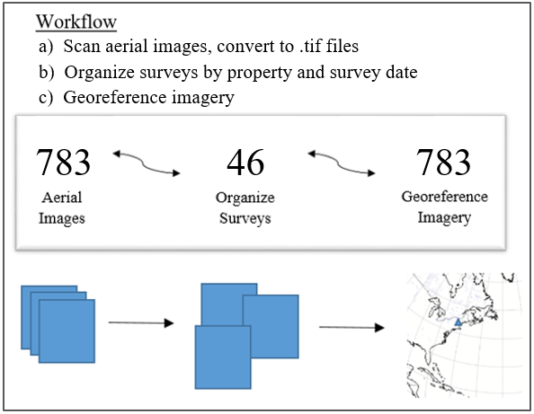
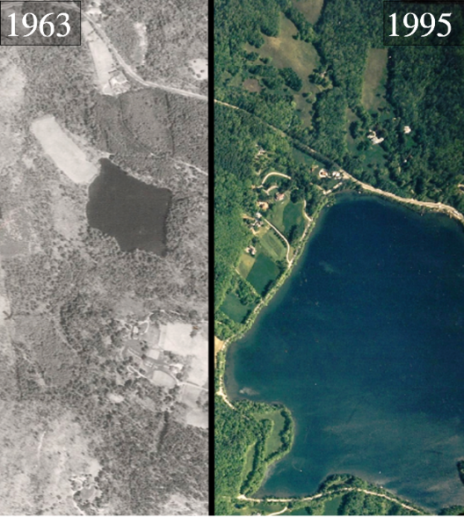

Block 7, Brewster Lot in Dublin, New Hampshire in 1963 and 1995.

Dates
Scanned 2019-07-30
Archived 2019-10-04
Georeferenced 2020-08-07

Extent
45.14716, -72.41413
42.75725, -70.75277
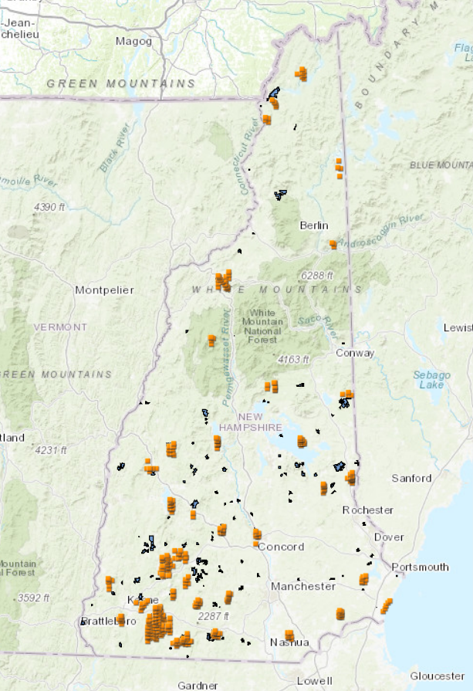
SPNHF Property
Georeferenced Aerial Imagery

Example
