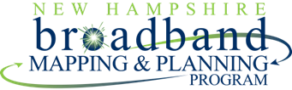

2016 Broadband Report:
Coos County, New Hampshire
June 2016

Broadband “high speed internet access” has clearly become an integral part of New Hampshire’s economy. It is critical for creating and maintaining jobs and for supporting public safety, education, healthcare, tourism, business, and our overall quality of life. The state must continually promote expanded broadband access and adoption in order to remain competitive with our neighboring states, with Canada, and globally. To do so effectively, a thorough understanding of the ever changing broadband landscape is required - particularly in northern New Hampshire where broadband gaps continue to persist.
Under the auspices of a grant from the Northern Border Regional Commission, the New Hampshire Broadband Mapping & Planning Program (NHBMPP) at the University of New Hampshire (UNH) initiated a project in late 2014 to extend and enhance broadband availability mapping and related outreach activities in the 43 communities in Coos County, New Hampshire. This comprehensive effort incorporated data collection, data analysis, and data visualization/map generation, in order to: 1) provide an enhanced and ongoing picture of the broadband landscape in Coos County by identifying areas that are unserved or underserved; 2) work with communities, regional agencies, and broadband providers to ensure that they are aware of the broadband gaps identified; and 3) utilize geospatial modeling tools to deliver a generalized cost estimate for additional broadband deployment in Coos County.
Figure 1. FCC’s Increasing Broadband Thresholds
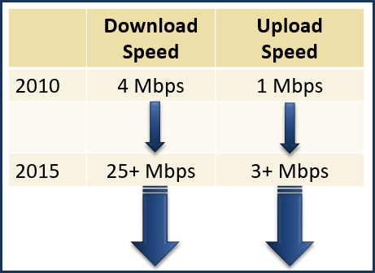
In 2015, the Federal Communications Commission (FCC) released an updated broadband standard, defining broadband as a minimum download speed of 25 Mbps and a minimum upload speed of 3 Mbps¹. These levels represent the minimum download and upload speed the FCC considers necessary to take advantage of the full range of today’s broadband applications – applications that integrate high-quality voice, data, graphics, and video. They are the most recent in a succession of broadband speed thresholds that will continue to increase in the future (see Figure 1).
Based on the 2015 FCC broadband standard, the most recently available FCC Form 477 data² indicate that 1,233,961 residents of New Hampshire, or 93.7% of the 2010 total population of 1,316,470, have access to broadband service and are therefore considered “served”. An additional 79,826 persons, or 6.1% of the state’s population, have access to the Internet at speeds of between 6 and 25 Mbps down and between 1.5 and 3 Mbps up. These residents are considered “underserved”, as their access is at speeds less than those required to fully utilize broadband services. The remaining 2,683 residents, or 0.2% of the state’s population, are effectively without Internet access.
Table 1 presents the population broadband availability data for New Hampshire at the county level. The table was generated from the June 2015 FCC data that includes fixed broadband deployment data as well as data from satellite providers, supplemented by data collected by the NHBMPP in September of 2014 from cellular providers. Thus the table reports on availability across all technologies, including cellular and satellite-based, although it is recognized that those two technologies may have limitations in terms of latency, reliability, and data caps. The table demonstrates the variability in access across the state, with the percentage of the population served by broadband ranging from a high of 99.2% in Rockingham County to a low of 75.7% in Cheshire County.
¹Federal Communications Commission, “2015 Broadband Progress Report”, https://www.fcc.gov/reports-research/reports/broadband-progress-reports/2015-broadband-progress-report
²Based on June 30, 2015, Version 2 data set, retrieved from https://www.fcc.gov/general/broadband-deployment-data-fcc-form-477

Overall limitations of the data are important to document, including the tendency for the data to understate broadband coverage as a result of underreporting by providers, and the tendency to overstate coverage as a result of aggregating data to the census block. These data limitations notwithstanding, tracking changes in broadband availability over time, and refining data to the address level, are vital to working with communities, providers, and regional agencies in all future broadband expansion efforts.

Table 1. Broadband and Other Internet Availability in New Hampshire by County based on Population
 |  | Served  (25+ Mbps down x  3+ Mbps up) |  | Underserved -  Other Internet Access  (6-25 Mbps down x  1.5-3 Mbps up)
County | Total Population (2010) | Population | % | Population | %
Belknap | 60,088 | 57,917 | 96.4% | 2,149 | 3.6%
Carroll | 47,818 | 46,157 | 96.5% | 1,638 | 3.4%
Cheshire | 77,117 | 58,363 | 75.7% | 18,148 | 23.5%
Coos | 33,055 | 25,820 | 78.1% | 5,587 | 16.9%
Grafton | 89,118 | 80,724 | 90.6% | 8,203 | 9.2%
Hillsborough | 400,721 | 381,214 | 95.1% | 19,470 | 4.9%
Merrimack | 146,445 | 135,196 | 92.3% | 11,153 | 7.6%
Rockingham | 295,223 | 292,870 | 99.2% | 2,353 | 0.8%
Strafford | 123,143 | 120,217 | 97.6% | 2,926 | 2.4%
Sullivan | 43,742 | 35,483 | 81.1% | 8,199 | 18.7%
State of New Hampshire | 1,316,470 | 1,233,961 | 93.7% | 79,826 | 6.1%

Broadband Availability in Coos County
Table 1 reports that in Coos County, 25,820 residents representing just over 78% of the 2010 population of 33,055, have broadband access. An additional 5,587 residents, or almost 17% of the population, have internet access at speeds that are not considered broadband, while 1,648 residents, or 5% of the population have no access at all. Figure 2 presents the geographic distribution of broadband availability in Coos County, and illustrates that full broadband access is limited to the southern tier of the county.

Figure 2. Broadband Availability in Coos County across All Technologies
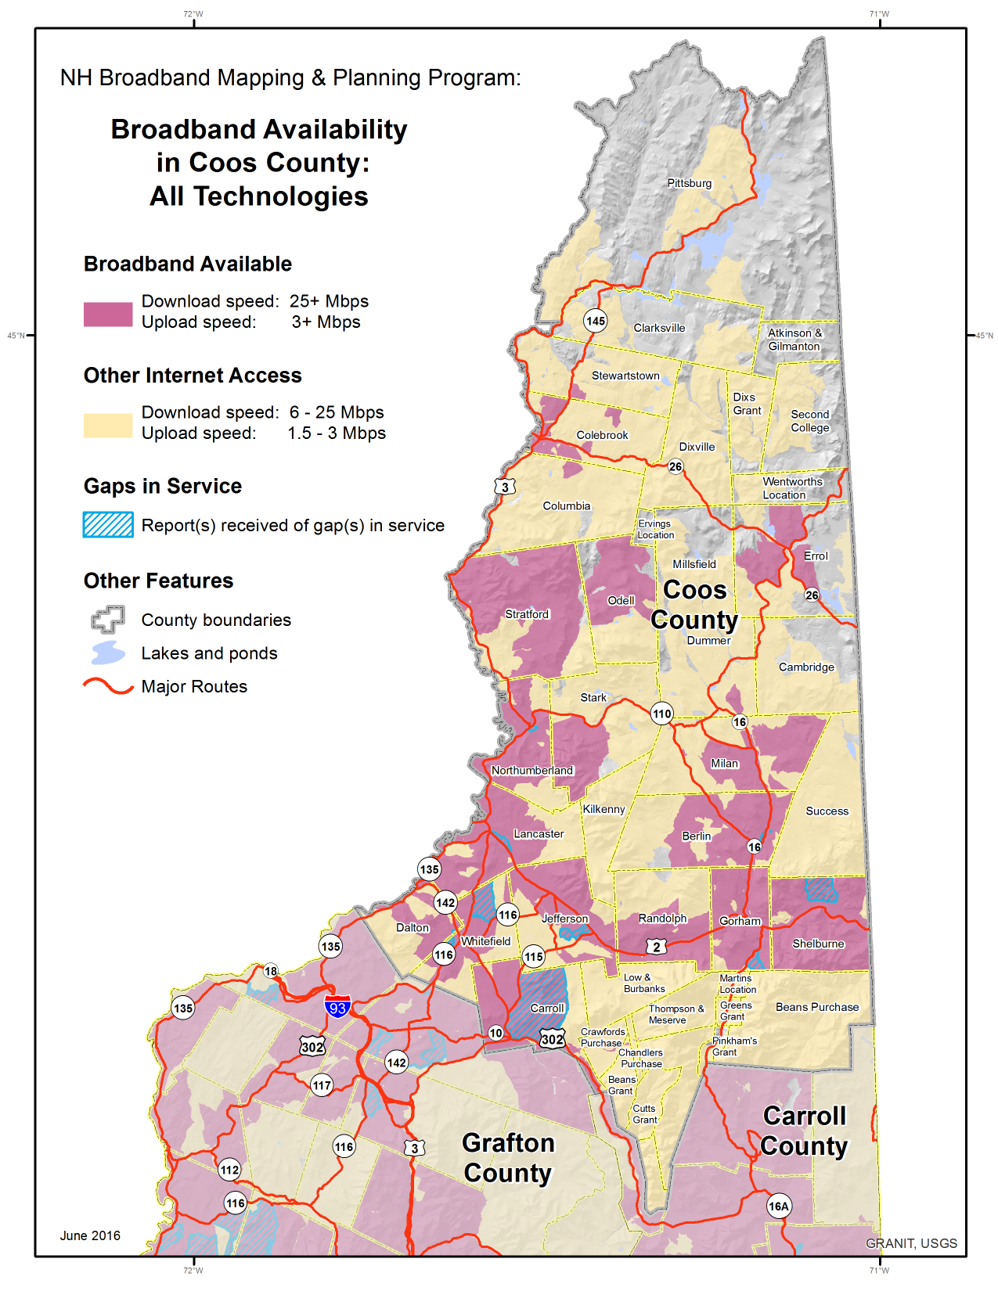
Source: https://www.fcc.gov/general/broadband-deployment-data-fcc-form-477
While the data used to develop the table and the availability map were submitted by broadband providers in a range of formats, all data were aggregated to the census block level for analysis and display. It is important to note that a census block was identified as served if at least one household or business in that block can purchase service. To address the likely overestimation of coverage that this definition yields, the NHBMPP has collected independent verification data via speed tests (collected over the period 2010-2016), user surveys, and local map review by community officials. The blue hash overlay in Figure 2 indicates that one or more of these verification sources identified the underlying census block as having areas that are not served, or have gaps in service.

Internet Service Providers in Coos County
An Internet Service Provider (ISP) is an organization that provides services for accessing, using, or participating in the Internet. ISPs may be organized in various forms, such as commercial, community-owned, non-profit, or otherwise privately owned. Table 2 below lists ISPs offering service in the Coos County region based on the types of technology they deploy and the class of service they provide³.

Table 2. Coos County Internet Service Providers
Technology | Provider | Class of Service
Cable | Time Warner Cable Inc. | Business/Residential
Cellular | AT&T Mobility LLC | Residential
 | United States Cellular Corporation | Residential
 | USAT Corp. | Residential
 | Verizon Wireless | Business
Fiber | Bretton Woods Communications | Business
 | PAETEC Communications Inc. | Business
Fixed Wireless | King Street Wireless, L.P. | Business/Residential
 | Wireless LINC/NCIC | Business/Residential
Satellite | dishNET Satellite Broadband, L.L.C. | Residential
 | GCI Communications, Corp. | Business
 | HNS License Sub, LLC | Business/Residential
 | Skycasters, LLC | Business/Residential
Copper-Wireline (T1) | BayRing Communications | Business
 | EarthLink Business, LLC | Business
 | MCI (Verizon Business) | Business
xDSL | FairPoint Communications | Business/Residential
xDSL, Fiber | FirstLight | Business

Broadband Speed Tests in Coos County
An internet (broadband) speed test is a tool that measures the speed of the connection between a local computer and a computer (server) on the internet. The measurement calculates how fast information travels from the local computer to the server (upload) and from the server to the local computer (download). Speed test tools often also measure latency, which is the amount of time the server takes to respond to a request. Results are typically reported in Mbps (megabits per second).
The NHBMPP established a speed test server at UNH in Durham, to measure broadband download/upload speeds from locations throughout the state. People interested in testing their broadband speeds can access the test at nhspeed.org. The test results are important data elements that contribute to our ability to map and monitor broadband access in the state, as well as our ability to verify that the available speeds are within an acceptable range of the services advertised by ISPs.
³Based on providers who submitted Form 477 data to the FCC and are represented in the June, 2015 data set. Other providers offer service in Coos County (including TCC Networks/Skywire, Fibercast, etc.) and some providers listed may offer additional types of services (including FairPoint), but information on the geographies they serve is not currently available.

Table 3 below reflects speed test data collected from 114 testers, from 19 municipalities in Coos County. The results have been aggregated to indicate the average download and upload speeds and the range of test results from each location.

Table 3. Coos County Speed Test Data
 |  | Average Download Speed  (Mbps) |  | Average Upload Speed  (Mbps)
Town | # of Speed Tests | Average | Range | Average | Range
Berlin | 24 | 3.285 | .150-10.441 | 1.027 | .098-3.929
Carroll | 3 | 1.513 | .124-2.329 | 6.232 | .121-18.354
Colebrook | 10 | 3.637 | .681-8.222 | 3.506 | .131-11.945
Dalton | 5 | 1.897 | 1.276-3.127 | 0.897 | .047-1.666
Dummer | 3 | 3.639 | 2.508-4.657 | 1.047 | .737-1.507
Errol | 1 | 5.885 | 5.885-5.885 | 0.965 | .965-.965
Gorham | 7 | 2.944 | .587-10.164 | 3.980 | .369-12.370
Jefferson | 11 | 3.907 | .807-6.542 | 1.689 | .117-5.344
Lancaster | 12 | 5.679 | .673-16.269 | 2.111 | .261-11.235
Milan | 4 | 3.225 | 1.367-5.549 | 1.371 | .486-3.381
Northumberland | 3 | 3.821 | 1.936-5.230 | 1.566 | 1.069-1.933
Pittsburg | 8 | 2.195 | .661-4.083 | 0.702 | .118-1.680
Randolph | 1 | 7.081 | 7.081-7.081 | 0.665 | .665-.665
Shelburne | 4 | 3.221 | .842-8.139 | 0.716 | .101-1.054
Stark | 2 | 1.912 | 1.124-2.700 | 2.938 | 1.482-4.394
Stewartstown | 1 | 0.176 | .176-.176 | 0.065 | .065-.065
Stratford | 1 | 5.490 | 5.490-5.490 | 0.968 | .968-.968
Wentworths Location | 1 | 0.048 | .048-.048 | 0.113 | .113-.113
Whitefield | 13 | 3.095 | .105-8.110 | 0.756 | .045-2.936
Coos County | 114 | 3.416 | .048-16.269 | 1.710 | .045-18.354
Source: http://nhspeed.org, data collected from 2010-2016.

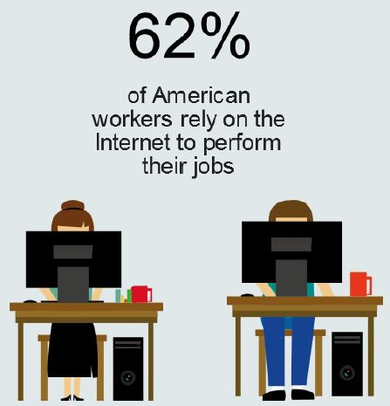
Broadband Opportunities by Sector
Jobs related to broadband and information technology are expected to grow by 25% between 2008 and 2018, a rate 2.5 times faster than the average for other occupations and industries. It has been estimated that in New Hampshire, significantly increasing broadband availability and adoption could create more than 11,000 jobs and $634 million in economic impact annually.
For New Hampshire businesses, broadband helps improve efficiency, expand markets, reduce costs, and increase revenues. According to the National Broadband Plan (FCC, March 2010), by using web-based technology tools, 68% of businesses surveyed nationally boosted the speed of their access to knowledge, 54% saw reduced communications costs, and 52% saw increased marketing effectiveness.
Source: FCC, www.broadband.gov 2011

In the public safety sector, personnel need the ability to communicate quickly with each other, access online resources via personal computers or mobile devices, and transfer critical video and information during emergencies. Broadband can enable first responders to share information digitally and in real time with hospitals and emergency facilities from the ambulance or point of response. Broadband supports mobile command-post operations and remote access to databases, such as criminal history and medical records.

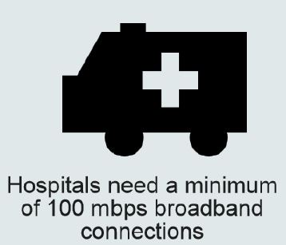
In the healthcare sector, emerging technologies can improve health outcomes while controlling costs and extending the reach of providers. Many of these technologies depend on broadband. They include online billing systems, data management, electronic health records, prescription management, health information exchanges, and providing information and services to patients online. Patients can benefit from remote consultations with specialists and the high-speed transmission of medical images and records without having to leave their community health center or, in some cases, their home.
Source: HealthIT.gov 2014
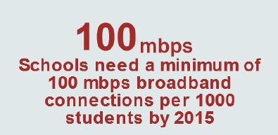
Reliable broadband technology is an important tool for education. Broadband can extend learning beyond the classroom, provide more customized learning opportunities, and increase the efficiency of school systems. A wide range of Internet-based resources—such as distance learning programs, online learning modules, and digital textbooks—allows students to engage in multimedia lessons, take virtual trips, and communicate with classrooms in other parts of the world. Broadband also provides adult learners easy access to online professional development and educational opportunities, and offers educators a platform to share curricula.
Source: State Educational Technology Directors Association (SETDA) 2013
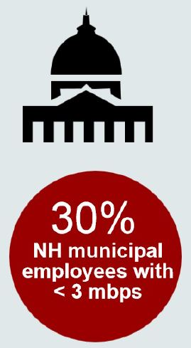
In addition, broadband helps local government to deliver services efficiently and cost-effectively. Most towns in New Hampshire now host websites providing immediate remote access to public notices, event calendars, applications, forms, ordinances, and regulations. Broadband also serves as a powerful communication tool for local governments, enabling more frequent and robust public engagement with residents. At NHBMPP-sponsored focus groups and interviews, municipal representatives identified the importance of having reliable, redundant broadband connections for both the municipality and its residents as a key broadband issue.
Source: NHBMPP Towns and Cities Survey 2012
Current Broadband Initiatives – Coos County and Region
Northern Community Investment Corporation (NCIC)
NCIC works to increase wireless broadband, fiber optics and cellular coverage across the region. These improvements help to make current and potential businesses within the region more competitive on a national and international scale, improving employment opportunities. Quality of life for residents also improves as a result. In recent years Wireless LINC Internet Service has been introduced providing residential and commercial broadband service. To learn more about NCIC’s infrastructure initiatives, contact Cathy Conway via email at: cconway@ncic.org
Coös Economic Development Corporation (CEDC)
Created to promote economic opportunity and business development, CEDC provides continuing support for existing and new businesses within Coös County. It facilitates Community Development Block Grants, maintains a revolving loan fund, administers the Coös County Economic Development Funds and provides grants for business technical assistance.
North Country Cell Service (NCSS) Initiative
The North Country Cell Service (NCCS) Initiative is a public/private partnership consisting of Northeast Utilities/Eversource, Wireless Partners dba Great North Woods Wireless, TCC Networks, 186 Communications, Ericsson, Green Mountain Communications, DED/DRED, Colebrook Development Corp (CDC), grantee Coos Economic Development Corp (CEDC), and the Northern Border Regional Commission (NBRC) to bring first time cellular voice service and high capacity broadband to northern Coos County. The CEDC was awarded a $240,000 NBRC grant and has secured match coming from the partners. The initiative is also using the NBRC funds to leverage other public/private funding and existing infrastructure improvements with a 3rd phase approach deploying as many sites as needed to provide ubiquitous coverage throughout Coos County. Recent activities include deployments in the towns of Pittsburg, Milan, Groveton, and Errol.
NetworkNH (UNH)
Network NH Now (NNHN) is designed to provide broadband connectivity that is symmetrical and capable of delivering current and next generation services that are comparable to the rest of the country. The end result will enable many social service, non-profit and commercial organizations to receive reliable service without having to pay for expensive copper-based connections. NNHN will alter the current reality for many areas of the state that prevent New Hampshire from being competitive and that impinge on the ability to attract potential businesses and investment.
New Hampshire School Connectivity Initiative (NHSCI)
Governor Maggie Hassan and Commissioner of Education Virginia Barry announced in early 2016 the New Hampshire School Connectivity Initiative (NHSCI), a collaborative effort tasked with enhancing high-speed broadband access for K-12 public schools in New Hampshire. NHSCI is spearheaded by the New Hampshire Department of Education and is comprised of the following organizations: the New Hampshire Office of the Governor, the New Hampshire Department of Education, the New Hampshire Department of Information Technology, the New Hampshire Department of Resources and Economic Development, and the University of New Hampshire. The goals of NHSCI are to: 1) Compile a comprehensive K-12 broadband connectivity report based on analysis and reporting of data collected by NHSCI. This effort was initiated in late 2015 by the University of New Hampshire and the Education Sub-Committee of the NH Governor’s Telecommunications Planning and Development Advisory Board (TAB); 2) Develop a plan to meet K-12 connectivity goals through the facilitation of statewide K-12 fiber network discussions with school districts, service providers, and partner organizations with the long-term goal of ensuring that all public school students across New Hampshire can take advantage of digital learning; 3) Create a strategy to enhance the utilization of E-Rate funds that are used to provide discounted communication services to schools and libraries across the state. NH currently receives less than 30% of the funds collected by the Federal Communications Commission through the Universal Service Fee paid by NH businesses and residents.

ConnectNH (UNH)
ConnectNH is a public/private partnership of nearly 60 organizations throughout New Hampshire. Formerly the Granite State Distance Learning Network, it is dedicated to developing and implementing an affordable, interactive videoconferencing network utilizing high-speed telecommunications capacity that ultimately will make interactive video networking and high-speed Internet access available in every New Hampshire community. The primary goal is to assist in delivering distance learning, professional development, community-based video conferencing, outreach, telehealth and high-speed access to the Internet across the state. When fully implemented, everyone in New Hampshire will have access to a broad range of educational and telehealth opportunities from around NH and the world without the need to travel more than 30 minutes from where they live or work. Coos County ConnectNH Sites: Colebrook School District, Colebrook; North Country Educational Services; Gorham; White Mountains Community College, Berlin; Pittsburg High School, Pittsburg; UNH Lancaster; Androscoggin Valley Hospital, Berlin; Northern Human Services, Groveton; Weeks Hospital, Lancaster; Northern Human Services, Colebrook; Upper Connecticut Valley Hospital, Colebrook; Northern Human Services, Berlin.
FirstNet
The First Responder Network Authority (FirstNet) mission is to build, operate and maintain the first high-speed, nationwide wireless broadband network dedicated to public safety. FirstNet will provide a single interoperable platform for emergency and daily public safety communications. This broadband network will fulfill a fundamental need of the public safety community as well as the last remaining recommendation of the 9/11 Commission. FirstNet will bring 21st century tools to millions of organizations and individuals that respond to emergencies at the local, state, tribal and federal levels. According to John T. Stevens, the NH Single Point of Contact (SPOC) and Statewide Interoperability Coordinator (SWIC), “FirstNet is not a state concept, but rather a community concept... we will continue to coordinate activities on the national and regional level, while our focus remains committed to the state, county, local, the private sector, non-governmental organizations and the military (NHNG) throughout New Hampshire and encourage their participation as partners and as stakeholders.”
Fairpoint – CAF Phase II
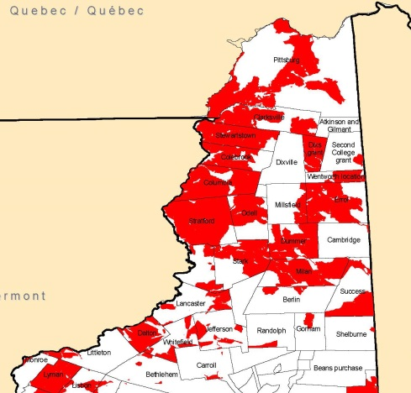
FairPoint, in August 2015, accepted $4.4 million in annual support from the FCC Phase II of the Connect America Fund (CAF) for the state of New Hampshire. By accepting these funds, the Company is committing to construct and operate network infrastructure and offer broadband service speeds of at least 10 Mbps download and 1 Mbps upload to over 13,000 locations in New Hampshire. The support program and the FairPoint commitment run over six years. The FCC developed CAF as a part of its mandate to shift federal support from voice service to broadband build out and operation in high cost service areas. Qualifying locations eligible for service as a part of the six-year build are determined by the FCC.

Moving Forward
Broadband, or high-speed Internet access, is critical infrastructure to ensure that the state’s residents and businesses are connected locally, nationally, and globally. Currently, broadband in Coos County is available to approximately 78% of the residents and there remain areas with limited or no broadband access. While progress is being made to improve access, Internet Service Providers, businesses, decision makers, and concerned citizens need to work together to expand access to ensure the tools are available for creating and maintaining jobs and for supporting public safety, education, healthcare, tourism, business, and the overall quality of life.
In addition, the cost of broadband service makes it unaffordable to a number of New Hampshire businesses and residents. Much of the state has coverage from only one or two wire-line broadband providers, and this lack of competition can lead to higher prices, while not increasing available speeds. New Hampshire needs to encourage competition among providers to bring the lowest possible cost to consumers.
Not all residents of Coos County who have access to affordable broadband services take advantage of the opportunities. Many small businesses and residents are unaware of the wide range of applications, information, communication and services available on-line. New Hampshire needs to continue to coordinate, promote, and sponsor trainings for residents, businesses, and organizations on the benefits of broadband usage. Increased skills and knowledge of broadband applications encourages broadband use and will lead to a well-educated, prosperous, healthy, and a safe New Hampshire.
Finally, New Hampshire needs to monitor, inventory, and evaluate its broadband availability, affordability, adoption, and competitive position on an ongoing and regular basis. Continuing to collect statewide broadband availability and adoption data is necessary in order to measure the effectiveness of broadband efforts and to provide a clear picture of New Hampshire’s broadband competitive position in comparison to other states, to Canada, and globally.

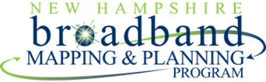

To learn more about the NHBMPP Coos County Broadband Project and to access interactive maps, please go to:
iwantbroadbandnh.org
Acknowledgments
The New Hampshire Broadband Mapping & Planning Program (NHBMPP) is managed by the New Hampshire Geographically Referenced Analysis and Information Transfer System (NH GRANIT) within the Earth Systems Research Center at the University of New Hampshire (UNH), and is a collaboration of multiple partners around the state.
The “Broadband in Coos County” project is partially funded by a grant from the Northern Border Regional Commission (NBRC), established to target resources to promote economic growth strategies and projects within the northern portions of the four state region of Maine, New Hampshire, New York and Vermont.

