Municipal Board Empowerment Series Workshop #4
NH Coastal Viewer 101 for
Land Conservation

http://nhcoastalviewer.org

Exercises
September 6, 2017

NH Coastal Viewer Training Exercise 1: Explore the NH Coastal Viewer
The NH Coastal Viewer allows users to view and manipulate data online, with a focus on coastal data and hazards. Exercise 1 will present an overview of the Coastal Viewer and introduce its basic functions. Begin by accessing the NH Coastal Viewer from http://www.nhcoastalviewer.org
- Get to know the Interface
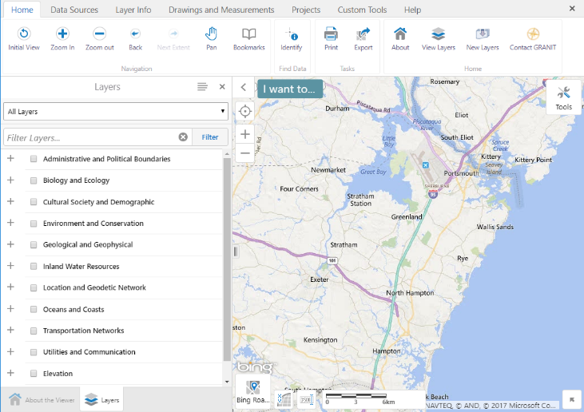
  - When you first access the Coastal Viewer, you will open the About the Viewer panel. Check here for general background information as well as announcements about new data and/or tools that become available.
  - Start exploring the Coastal Viewer interface. Note that Tools are arranged in Tabs along the top of the Viewer (e.g. Home, Data Sources, etc.) Click on each tab to see what tools are available, then return to the Home tab.
  - To begin using the interactive map, click the Layers tab in the lower left corner to open the Layers panel and view the Table of Contents (TOC).
  - Turn on and off the Overview Map by clicking the arrow in the lower right corner of the Map Area. Change the map scale by clicking on the Nominal Scale to the left of the scale bar and selecting “144,448” from the dropdown box.

- Turn on Data Layers
  - Display the Town/City boundary layer from within the Administrative and Political Boundaries (APB) folder on your map by checking the appropriate boxes.
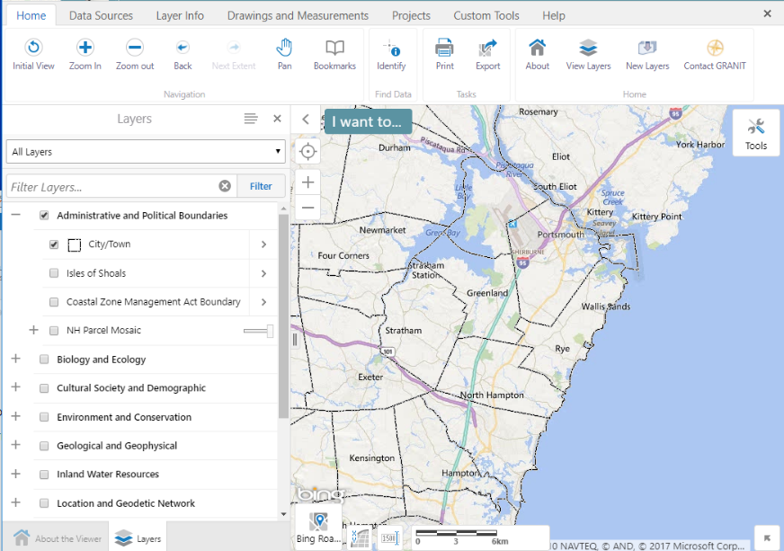
  - Expand and collapse data categories by clicking the +/- symbols. Here, start by expanding the APB folder.
  - Check both the folder name and the City/Town layer. Note that all levels of the hierarchy must be checked for data to be visible.
- If you accidentally close the Layers panel, you can open it again by clicking the View Layers tool (found in the Home tab of the toolbar).
- Try expanding other folders and displaying additional data sets of interest. Remember to expand and click on all levels of the layer hierarchy to fully expand folders and display a data set.
  - Note: Layers in the TOC that appear in gray font are scale-dependent, and will only draw when the map is zoomed in and the font color changes to black.
- Navigate within the Map Area (Zoom, Pan, etc)
  - To Zoom In/Out, click the Zoom In or Zoom Out tool, then drag a box in the map area. Use the Zoom In tool to zoom into the town of North Hampton.
  - Each time you want to zoom, you must re-click the appropriate Navigation button.
  - Click the hand icon to Pan west to the town of Stratham; click Back to return to previous extent.
  - Initial View returns the map to the default extent. Click on this tool, and then zoom into another location of interest.
- Note: You can also zoom using the +/- buttons in the map area or by using your mouse wheel.

- Change the Background Image for your Map
- When you open the Coastal Viewer, the background image displayed is a road map (from Bing.com). There are several other base map options available from Bing and other external sources, including Bing imagery, Bing hybrid (both imagery and road features), USGS topo maps, etc.
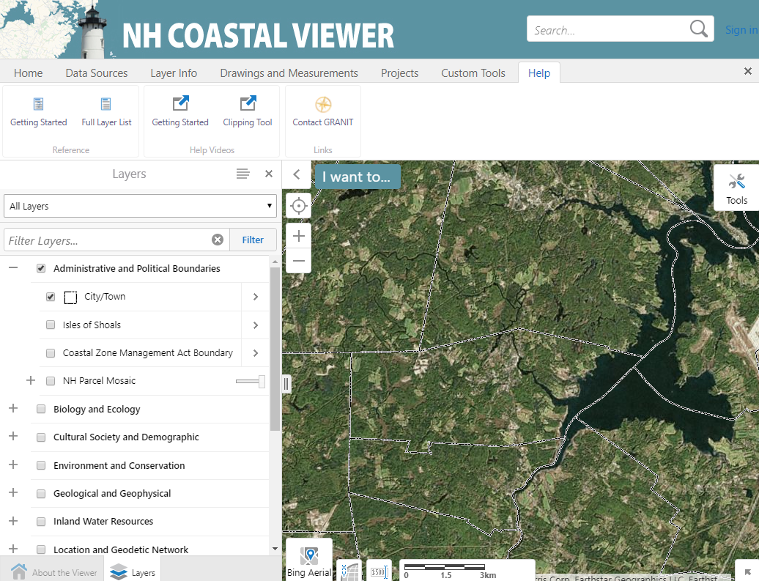
- Click on the “Bing Roads” icon in the lower left corner of the map display to see the other base map options. Change your selection to “Bing Aerial”.

- There are also image options available from GRANIT in the TOC. Scroll down to the bottom of the layer list, expand the “Base Maps/Aerial imagery” folder, expand the subfolders, and explore these additional options.
- Filter data in the Table of Contents
  - There are over 200 data layers presently available for display in the Coastal Viewer. Filter allows you to search for a specific data layer by name.
  - Type a keyword into the Filter box, and the Layers List will display only those layers that match your search criteria. Enter “conservation” in the text box to list data sets that include that term in their name.
  - Click on parent folder (Environment and Conservation) and the Conservation and Public Lands data layer to display the data set. When you are done, uncheck the data layer so it no longer displays. (You do not need to uncheck the Environment and Conservation folder.)
  - Filter searches based on the title of the layer, so try other keywords if you don’t see what you want.
  - Click the x in the upper right corner to return to the full Layers list.

- Access Layer Actions
  - Layer Actions are actions you can initiate to modify the way data are displayed, show feature labels, or learn more about individual data sets.
  - All actions are not available for every data layer.
  - Expand and check the Cultural Society and Demographic folder, and display the Access to Public Waters layer on your map. (This layer is scale-dependent; you may need to zoom in to display the data.) You see the legend for this data layer in the TOC. Click on the legend icon to collapse the legend.
  - Click the arrow next to Access to Public Waters to view available Layer Actions for this layer.

- Turn On/Off Layer Visualizations
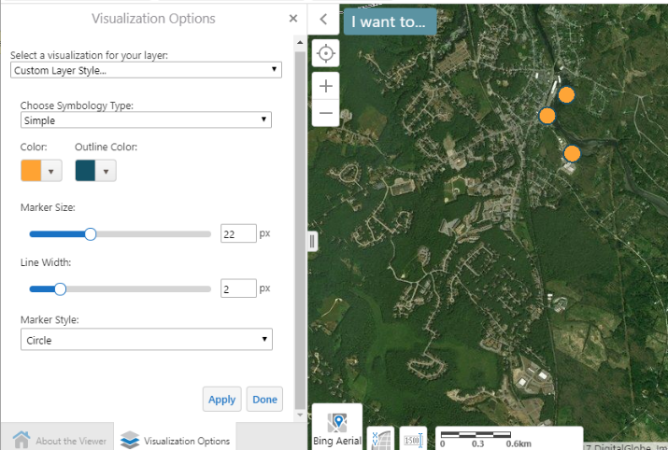
  - To change the way a layer is displayed, click Turn on/off layer visualization.
  - Choose Custom Layer Style… from the visualization dropdown.
  - Symbology Type can be Simple (all features displayed with one symbol), or by Attribute. For now, change the symbol for all public access points to display as orange by selecting “Simple”, clicking on the Color selector box, selecting orange, and clicking on “Apply”.
  - Use the sliders to adjust the Marker Size, and Line Width if you wish. (Because the data layer being displayed is a point layer, the Line Width option will change the width of the symbol outline.) Again, click “Apply” when ready.
  - To return to defaults, select “None” under “Select a visualization for your layer”, and then click on “Done”.
  - Click on the x in the upper right corner of the open Layer Action Panel to return to the Table of Contents.
- Use the Identify Tool to View Data Attributes
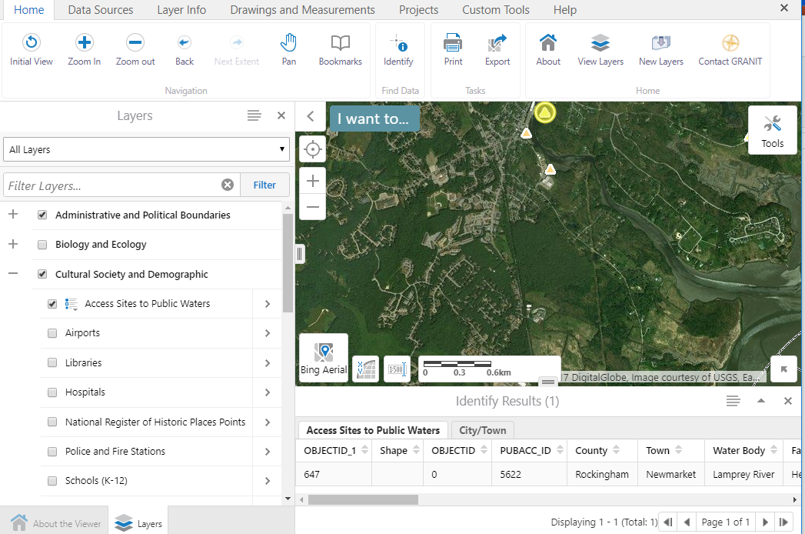
  - From the “Home” tab, click Identify in the Toolbar, then click on a single access site point in the map to view its attributes. The attributes will display in a table below the map.
  - Results will be provided for all data layers that are checked to display; to view results for other layers, click on the appropriate tab in the Identify Results window.
  - Close the Identify Results box by clicking the x in the upper right corner.

- Read Metadata
  - How can you find out what the codes in an attribute table stand for? Read the metadata!
  - In the Layer Actions menu, click Metadata. This will open a new browser tab, and bring you to the main GRANIT data distribution site.
  - Next click “Full Metadata and Data Download”, then click the link to “Full Record”.
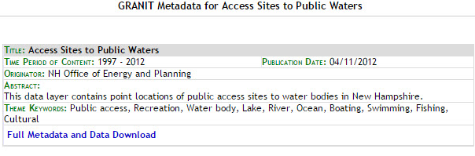
  - To find the definition of Attributes, click “Entity_and_Attribute_Information” to jump to this section of the metadata document.

- Other information available from the metadata record includes who developed the data, when it was last updated, and what methodology was used to generate the data.

  - Note that you opened additional browser windows as you clicked through the steps above. Return to the NH Coastal Viewer tab, and Click on the x in the upper right corner of the open Layer Action Panel to return to the Table of Contents.

- Access Help Documents
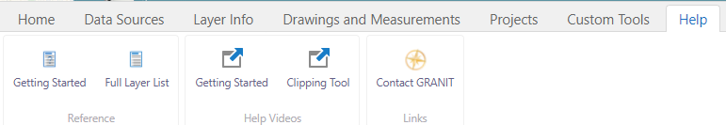
  - Click the Help tab in the Toolbar. There are both reference documents and help videos available from this tab.

- “Getting Started” provides guidance on starting to use the Coastal Viewer. Both a .pdf document and a brief help video are available.
  - “Full Layer List” provides a complete listing of all data sets available to display. It is recommended that you review this to get an understanding of how data layers in the Coastal Viewer are organized.
  - The “Clipping Tool” video provides help with a specific tool (see Exercise 3).

Remember! If a data set you would like to map doesn’t display, make sure you have checked all boxes in the layer hierarchy (e.g. all folders and subfolders as well as the individual data layer name). Also, recall that some complex data sets may have scale-dependencies set, and will only display when you are zoomed in.

