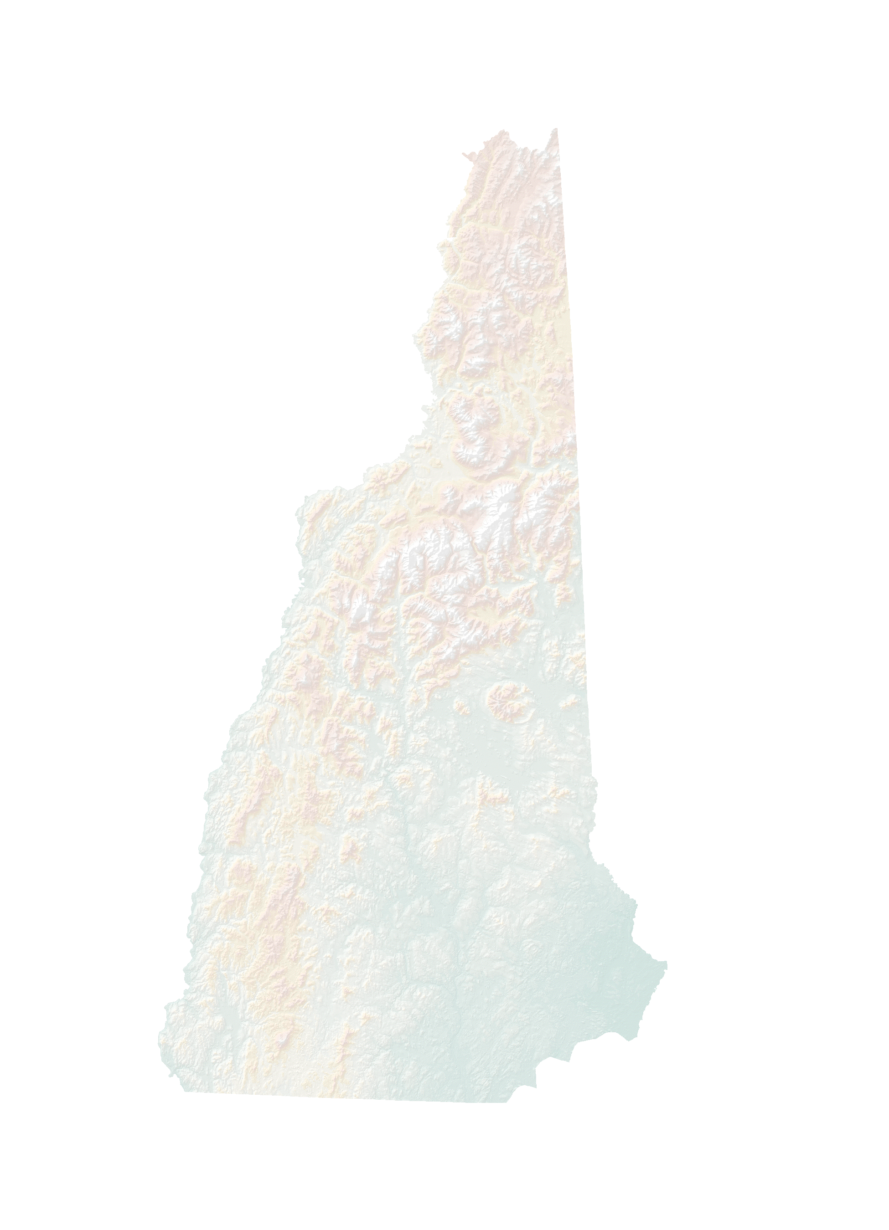

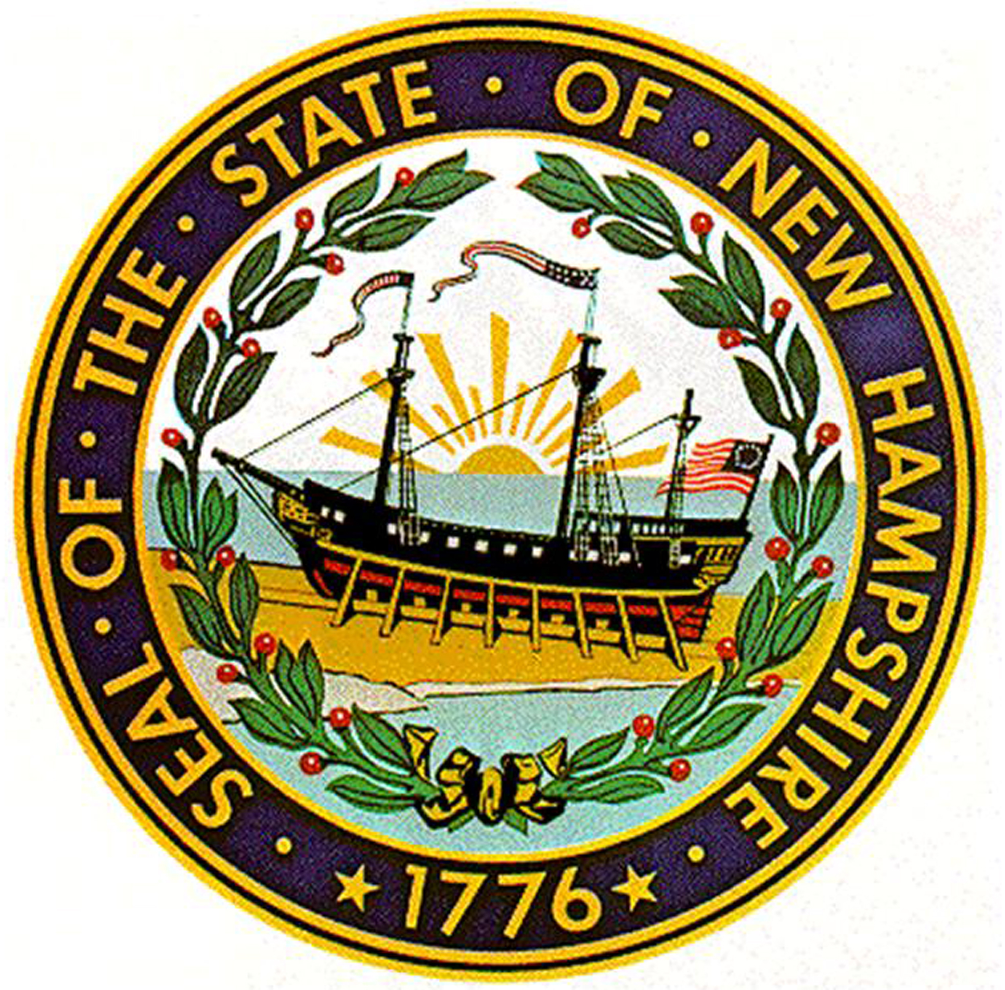
State of New Hampshire

Business Plan:
For a Geospatial Information Officer (GIO)

July 10, 2007

The development of this document was funded by the Federal Geographic Data Committee (FGDC) through a National Spatial Data Infrastructure (NSDI) Cooperative Assistance Program (CAP) Grant in Fiscal Year 2006, Award Number 06HQAG0119, as part of the Fifty States Initiative. It was developed by Applied Geographics, Inc. (AppGeo) in collaboration with the New Hampshire GIS Strategic Planning Advisory Committee.



www.appgeo.com

Foreword

New Hampshire initiated this project by forming a GIS Strategic Planning Advisory Committee (GSPAC), composed of a diverse set of stakeholders chosen from the broader GIS Advisory Committee. The GSPAC was led by Ken Gallager from the New Hampshire Office of Energy and Planning (OEP). Mr. Gallager also serves as the Coordinator for the statewide GIS Advisory Committee, which was chartered 20 years ago by the Council on Resources and Development (CORD). The GSPAC members are:

State Agency Representatives:
- Ken Gallager, Chair, NH Office of Energy and Planning
- Dennis Fowler, NH Department of Transportation
- Janet Horne, NH Department of Health and Human Services
- Rick Chormann, NH Department of Environmental Services
- Rebecca Bolton, NH Office of Information Technology
Academic Representative:
- Fay Rubin, University of New Hampshire, GRANIT
Federal Agency Representative:
- Lynn Bjorklund, USGS
Regional Planning Commission Representative
- Tara Bamford, North Country Council (formerly with Upper Valley Lake Sunapee Regional Planning Commission)
Local Government Representative
- John Vogl, Town of Londonderry

This project was funded in part by the Federal Geographic Data Committee (FGDC), through a National Spatial Data Infrastructure (NSDI) Cooperative Assistance Program (CAP) Grant in Fiscal Year 2006, Award Number 06HQAG0119, as part of the Fifty States Initiative. Following a competitive procurement, Applied Geographics, Inc. (AppGeo), of Boston, Massachusetts, was selected to assist the GSPAC in its planning efforts. The project resulted in both a Strategic Plan and a Business Plan to advance statewide spatial data infrastructure and services in the State of New Hampshire.

Document History
This Business Plan is intended to be a “living document”, and it will be periodically updated by the NH GSPAC team. A document history for version tracking is located in the Appendices.

Copyright Notice

The GIS Business Plan document is the Property of the State of New Hampshire and its subdivisions. All permitted copies shall be reproduced with all titles, logos, copyright notices, trademark notices, and legends included in the original materials.

Table of Contents
1 Executive Summary 1
2 Program GOALS AND objectives 3
3 PROGRAM REQUIReMEnts and Benefits 4
3.1 Cross-Departmental Issues and Needs 5
3.2 Importance of GRANIT 7
3.3 Alternatives to the GIO Initiative 8
4 Organizational approach 8
4.1 Geospatial Information Officer (GIO) 9
4.2 GIO Oversight 10
5 PROGRAM Costs 12
6 Implementation Plan 13
6.1 Two Year Implementation Plan 14
6.2 Programmatic Scorecard 14
6.3 Funding Plan 17
6.4 Education and Outreach Plan 17
7 Appendices 19

Executive Summary
The mission of the State of New Hampshire's GIS program is to promote the efficient use of New Hampshire's diverse resources by utilizing geographically related information in an effective way and by providing geographic information and corresponding tools to State agencies and the general public. If applied effectively, GIS is an asset to use in maintaining and enhancing the state’s rural character and economic well-being. A key success factor is an integrated GIS environment that is supported by technology, people, activities, and processes. With these elements in place, GIS becomes a highly effective tool that can support both broad and specific statewide policy issues, such as the following:
- Land use planning, growth management, and transportation planning
- Public safety, flood response and mitigation
- State education funding
Over the past 20 years, many millions of dollars have been spent on GIS in the State of New Hampshire – it has been a substantial investment. The state has extensive GIS infrastructure – both data and technical - in place at various levels of government and at the University of New Hampshire. A description of this infrastructure is provided in the NH GIS Strategic Plan (separate document). It is conservatively estimated that over $16 million has been spent by all levels of government in NH during the past three years alone, with nearly half of that amount spent by the State. Further, GIS use has been steadily expanding, suggesting that investments in the technology will continue to increase in the future.

The Problem
While the investment in GIS has been substantial and is likely to increase, there has been little statewide oversight or formal coordination on how the dollars are spent. No one is able to authoritatively say how much has been spent on GIS infrastructure, nor give a complete summation of benefits to date and needs going forward. However, there is a consensus among members of the statewide GIS Advisory Committee that the lack of authoritative coordination costs the state significantly, both from a financial perspective and more importantly, from lost opportunities for more effective information management and decision-making support.

While many of the components necessary for a comprehensive state spatial data infrastructure and tighter coordination are in place, several important limiting deficiencies were identified in the NH GIS Strategic Plan. These include:

- Lack of cohesion between state government GIS programs. GIS activity is focused at the departmental level with no formalized, central GIS office to facilitate data sharing, and no support for the technical infrastructure required to enable it. This has resulted in costly duplication of effort and inefficiencies. For example, the state has developed three separate road centerline data sets – the E911 data set, the DOT data set, and a USGS derived data set - that are in use and are being maintained to various levels of currency. In addition, many cities and towns have their own road centerline data sets.
- Lack of formal, broad and regimented sharing and collaboration between state government and GRANIT. The GRANIT System at the University of New Hampshire has served as the state’s GIS data clearinghouse since the mid 1980’s. However, some agency data sets are never submitted to GRANIT, while others are submitted on an irregular basis. Further, there is no infrastructure to allow automated, on-line synchronization between state databases and GRANIT. This has resulted in a lack of awareness of what data are available, or unnecessarily redundant data storage.
- Lack of formal coordination between state government and local government GIS efforts. While some collaboration and coordination takes place on an ad hoc basis, it is not widespread nor is there state guidance aimed at helping local GIS programs actively engage with state efforts. Improvements in coordinating such efforts would benefit many statewide studies, including the adequacy of funding for education. Improved coordination would also help the local communities to better understand the benefits and objectives of the State’s efforts.
- Major gaps in GIS data still exist. The NH GIS Strategic Plan identifies seven (7) core data layers that are needed by many departments for daily operations and by the state to address statewide policy issues, including those listed at the outset of the Executive Summary. One of the most commonly identified needs is for orthophotos, an important base map layer. Additionally, data sets as fundamental as municipal boundaries and elevation have significant shortcomings and are in need of improvement. Other key data sets are either unavailable or of low quality, e.g., drainage infrastructure data. Both elevation data and drainage infrastructure are important for flood preparedness and prevention, as well as other statewide issues. (See Appendix for table on Data Gaps)

The Solution
In order to develop strategies to address the abovementioned deficiencies and to implement the recommendations of the NH GIS Strategic Plan, the following recommendation is made: Create and fill the position of a Geospatial Information Officer (GIO) for the State of New Hampshire.

Plan of Action
The GIO position will be a full-time state government position with a sustainable funding source. The GIO position is envisioned to have both inter-departmental and inter-governmental coordinating responsibilities, and therefore, will report directly to the Governor’s Office. The annual cost of this position, salary, benefits, and overhead costs is estimated at approximately $180,000 to $190,000 per year, equivalent with that for the head of a state agency. To establish this position by 2008, support is being requested from the members of the Council on Resources and Development (CORD) to contribute to the funding until General Funds can be requested from the state legislature for the biennium period beginning in July 2009.

Program GOALS AND objectives
In order to capitalize on existing strengths and opportunities and to address existing weaknesses and threats, the NH GIS Strategic Plan describes several goals, primary of which is to Create and fill the position of a Geospatial Information Officer (GIO). This position should be a full-time state government position with a sustainable funding source, reporting to the Governor’s Office. In establishing a GIO position, New Hampshire will be keeping pace with similar functional roles established in New York, Massachusetts, Rhode Island, Pennsylvania, Virginia and Wisconsin (albeit not always with the same title) to formally coordinate statewide GIS efforts and infrastructure to gain economic advantages for their respective state.
The GIO will design and oversee a Program that addresses the objectives listed in the NH GIS Strategic Plan. The following table lists the years in which the objectives are proposed to be addressed. These objectives depend heavily on the initial creation of the GIO position; without the creation of this position, the State will not be able to achieve the remaining objectives in a timely manner.
Year | Activity
2008 | Create a State GIS Office
2009 | Legislatively recognize GRANIT as the focal point for a New Hampshire Spatial Data Infrastructure (NH-SDI)
2008 + | Increase awareness of GIS and what it can do, especially with State Legislators
2008 + | Expand support that is offered to local and regional GIS stakeholders
Ongoing | Develop strategies for capturing data to fill identified data gaps:  a. Definitive town boundaries  - High-quality topography  - High-quality imagery  - Parcels  - Drainage infrastructure  - Street centerlines and addresses  - Orthophotos

PROGRAM REQUIReMEnts and Benefits
The GIO will provide the leadership, capacity, perspective, and accountability required to tackle the objectives described above, thereby yielding an important set of identifiable benefits. A fulltime Geospatial Information Officer charged with the overall coordination and oversight of geospatial activities with state agencies as well as with the broader geospatial community, will significantly enhance the geospatial fabric of the entire state and will potentially realize tangible cost savings.

Geospatial Information Officer (GIO)

Requirements | Benefits
- Create cohesion between state government GIS programs  - Establish formal, broad and regimented sharing and collaboration between state government and GRANIT  - Establish formal coordination between state government and local government GIS efforts  - Close major gaps in GIS data | - Reduced or eliminated duplication of effort  - Increased availability of consistent and reliable GIS data  - Better decision-making support  - Shared development of critical data sets and infrastructure  - Formal guidance for GIS data collection – i.e., data standards  - Increased awareness of deficiencies or surpluses in terms of GIS resource allocation, and more efficiency  - Greater GIS support to local government and citizens

A more detailed description of expected benefits from having a GIO in NH follows:

- Accountability to ensure that significant and large departmental geospatial initiatives are coordinated across multiple stakeholders and that all parties are aware of these initiatives. Duplicative initiatives may be avoided through more effective communication and coordination. Opportunities for cost sharing, cost reduction, and product consolidation or refinement can more easily be explored.
- Oversight on the development of a broader GIS enterprise architecture that not only serves existing GIS initiatives at the state and local level, but also jump-starts activities in those agencies with limited or no resources to build a capacity themselves.
- Leveraging past and ongoing investments in GIS infrastructure to strengthen its use in support of public policy and decision-making activities in the state. There are significant opportunities to effectively utilize GIS in support of major state policy initiatives. The GIO will be in a position to offer a critical and informed perspective on how the technology may best address these and other important issues.
- Accountability for the development and implementation of data sharing protocols that can support the provision of data to the state’s Clearinghouse hosted at GRANIT, while at the same time providing assurance that data contributors’ interests are appropriately protected. The GIO will encourage agencies, regional planning groups, and local government units to fully participate in the Clearinghouse at GRANIT.
- Accountability for creating and promoting the adoption of geospatial data and system standards that support greater efficiencies of data exchange and costs savings through technology re-use.
- Oversight for the development of important core geospatial datasets that have cross-agency application and use.
- Providing primary and accountable point of contact for the Federal Government on geospatial data initiatives. There are many and significant geospatial initiatives occurring at the federal level that will continue to have a growing impact on state level geospatial activities, e.g., the collection of Critical Infrastructure datasets by the Department of Homeland Security (DHS), and the closely related Homeland Security Infrastructure Protection (HSIP) “Freedom” program co-sponsored by DHS and the National Geospatial-Intelligence Agency (NGA). A single state point of contact will help streamline those lines of communication and will ensure that the geospatial interests of the state as a whole are well represented. Likewise, the GIO will be responsible for knowing how best to leverage and apply national initiatives for the benefit of the state, e.g. Imagery for the Nation.
- Providing primary and accountable point of contact for Regional Agencies and Local Government units. Significant benefits accrue to the state when more accurate local data can be harnessed. Likewise, there are benefits to local governments through potential grant funding opportunities or training opportunities. The GIO will help forge win-win relationships with local government units, thereby building out the broader statewide geospatial infrastructure which will ultimately benefit the state.

Cross-Departmental Issues and Needs
The membership of the state’s Council on Resources and Development (CORD) includes a subset of departments that already realize significant value from the use of GIS data and technology and will continue to utilize and grow geospatial capability. For example, the Department of Transportation, Department of Environmental Services, and the Department of Safety are benefiting from the use of GIS in their core activities. Together with the GRANIT clearinghouse at UNH, these agencies represent some of the existing GIS infrastructure in the state. Details on their GIS activities and capabilities are described in the NH GIS Strategic Plan.

In general, CORD members recognize the need for a leader who will enhance coordination and communication between state agencies, perform necessary standards development, provide a primary point of contact for coordinating common data needs, and provide support, guidance, and training in geospatial technologies. If served by a GIO, departments can concentrate and focus their resources on primary business activities, rather than diverting resources to activities required in common across multiple agencies. In addition, certain statewide issues that require cross-departmental coordination and attention could be better served if GIS efforts were coordinated. The table below depicts the three statewide issues listed in the Executive Summary that will benefit from more tightly coordinated GIS efforts, and the CORD member departments that are either directly or indirectly involved in addressing the issues.

Direct Involvement = D
Indirect Involvement = I

 | OEP | DAS | DAMF | DCR | DOE | DES | F&G | DHHS | NHHFA | DRED | DOS | DOT
LU/GM/TP | D | I | D | I | I | D | D | I | I | D | D | D
PS/FR&M | D | I | I | I | I | D | D | D | I | I | D | D
SEF |  |  |  | I | D |  |  |  | I | I

LU/GM/TP - Land use planning, growth management, and transportation planning
PS/FR&M - Public safety, flood response and mitigation
SEF - State education funding

OEP - Office of Energy and Planning
DAS - Department of Administrative Services
DAMF - Department of Agriculture, Markets and Food
DCR - Department of Cultural Resources
DOE - Department of Education
DES - Department of Environmental Services
F&G - Fish and Game Department
DHHS - Department of Health and Human Services
NHHFA - New Hampshire Housing and Finance Authority
DRED - Department of Resources and Economic Development
DOS - Department of Safety (including Bureau of Emergency Management)
DOT - Department of Transportation

Geospatial technologies are being used to support discussion of these key issues in a variety of ways, including the selected examples presented below. Readers may also refer to the matrix of GIS Data Gaps in the Appendix, which lists shared geospatial data sets necessary to effectively address these issues.

Issue: Land use planning, growth management, and transportation planning
This statewide issue, or set of issues, involves all CORD agencies to some degree, and shared GIS data serves as a framework for developing a common perspective. DES may be concerned with water quality impacts associated with development patterns, while DOT focuses on the changing transportation infrastructure required to accommodate the state’s population base, and DCR looks to preserve historic and archeological sites.

Issue: Public safety, flood response, and mitigation
As with land use planning, all CORD agencies are involved in statewide issues related to the safety and security of the state’s citizens. The DOS mission is to protect the lives and safety of our citizenry. OEP addresses floodplain management issues in concert with the local communities they serve, while DAS and NHHFA may be more focused on potential impacts of flooding to state-owned property. The DHHS perspective may relate to concerns about breeding habitat for mosquitoes and other disease surveillance issues. DOE must be concerned with school and student transportation safety, while F&G routinely carries out Search & Rescue missions. DRED’s involvement in public safety may include concern over continuity of operations for business in the state. And the DAMF is vigilant about the safety of the state’s food supply.

State education funding
One of the primary GIS data gaps that has been identified – digital parcel data – would be of direct benefit in addressing issues associated with state education funding. While it is clear that is a direct concern to DOE, it may be less obvious that it also involves DRED, DCR, and HFA. The state’s attractiveness to businesses or individuals looking to relocate is partly a function of its education system. Many of the state’s cultural and historic resources are part of the inventory of schools, which need maintenance and repair. And, the state’s housing stock has bearing on its ability to accommodate the growth and changing demographics that impact schools.

  - Importance of GRANIT
The New Hampshire Geographically Referenced Analysis and Information Transfer System, or GRANIT, was formed in the early 1980’s and has since developed into a significant and important part of the state’s geospatial community through its provision of data, spatial data analysis, GIS applications, and project support. GRANIT is broadly recognized as the state’s representative GIS face, and will be both an important ally and a resource to the proposed GIO for achieving statewide GIS objectives. GRANIT is presently partially funded by a number of state agencies at the level of approximately $70,000 per year.

GRANIT provides to state agencies, local government, and the general public, access to significant GIS data holdings. Since March of 2000, GRANIT has responded to approximately 1500 requests for geospatial data files from the broad constituency that it serves. This number does not include those consumers who download the data directly from the GRANIT website. In recognition of GRANIT’s important clearinghouse role, many state agencies that create or maintain spatial datasets provide these data to GRANIT for hosting. There is clearly a significant need for both geospatial data and a dependable means by which it can be hosted, managed, and distributed.

Through the Data Mapper application, GRANIT is currently providing application level access to its geospatial data holdings for those entities that do not have tools for working with GIS data, and is beginning to expand into web-based image and vector services. Input from the workshops indicated that both the data (hosting and development) and application services provided by GRANIT are needed and well utilized.

Alternatives to the GIO Initiative
An alternative to implementing the GIO initiative is to allow the current state of operations to persist, i.e., to preserve the status quo. Though a legitimate position, this is not recommended. Even with a status quo posture, there will be a continued growth of GIS activities within each of the principal user agencies, and current non-user agencies will begin to utilize the technology. With uncoordinated geospatial activities developing and maturing, the state can anticipate greater duplication of effort, further inefficiencies, significant lost opportunities, and an increase in stove-piped GIS activities. These result in vastly increased costs as multiple agencies and partners pursue similar goals in an uncoordinated manner.

The Cost of Doing Nothing
The alternative of doing nothing is not without its costs. A few examples are given below:

- Social Costs – these may include the impact of poor or erroneous decisions resulting from insufficient or inaccurate data
- Diseconomies (a.k.a. spillover costs) – these may include the cost of data consumers being compelled to become data producers of commonly needed data layers, with associated inefficiencies and sub-optimal resource allocation
- Unnecessary Costs – these are costs associated with ongoing duplication of effort and other inappropriate allocation of resources from an enterprise perspective; duplicate street centerlines and redundant flyover efforts for aerial photography are examples.
- Missed Opportunities – the state will not be in a strong position to apply for and receive grants from the federal government for geospatial initiatives for which grant money is available and much needed to tackle known data gaps.

Organizational approach
The State of New Hampshire has already recognized the significant role of GIS data and technology tools. These data and tools are used extensively by many state agencies to better support the planning and management of land, water, and economic resources. Measurable cost savings and benefits can be achieved with better coordination and the shared development of critical datasets and technologies. In order to realize these economic advantages, there is a need to establish a position with the authority to make a difference. It is proposed that NH establish a full-time Geospatial Information Officer (GIO) for this reason. The role of the GIO will be pivotal in supporting the growth, development and further maturation of the geospatial business as applied to government. This is a unique role within the state, and one that can realize significant financial and other benefits at all levels of government.

Given the critical role to be played by the GIO, this business plan recommends additional organizational changes to ensure appropriate levels of governance and oversight. Specifically, the GIO will meet on a regular basis with a newly created State GIS Council to report on progress and benefit from expert advice and opinion. The GIO will likewise meet with a Technical Advisory Group, or TAG, which will represent the hands-on GIS community. Together these groups will help realize the vision of a much more effective state level GIS enterprise that meets the needs of a broad and diverse group of stakeholders.

Geospatial Information Officer (GIO)
The State of New Hampshire is not alone in pursuing a GIO or Statewide GIS Office. The recently published Federal Geographic Data Committee (FGDC) and National States Geographic Information Council (NSGIC) Fifty States Initiative document identified nine criteria essential for the effective statewide coordination of geospatial information technologies. These criteria were identified through an extensive review of what has worked well to create better results in states across the nation. Of the nine criteria identified, the first speaks to a GIO: “A full-time, paid coordinator position is designated and has the authority to implement the state’s business and strategic plans”.

Note: Sample GIO job descriptions can be found on the NSGIC website (http://www.nsgic.org/resources/index.cfm)

Since the GIO position is envisioned to have both inter-departmental and inter-governmental coordinating responsibilities, it is envisioned to be organizationally situated parallel to the Chief Information Officer and reporting directly to the Governor’s Office. The GIO position provides technical geospatial services to other agencies and clients similar to the CIO. As the State of New Hampshire builds out an IT Enterprise Architecture, it is important that the geospatial enterprise be fully integrated and partnered with the enterprise architecture. This is best achieved by establishing the GIO under the same director as the CIO, to foster a close working relationship between IT and geospatial information and technology. The GIO will provide coordination and support activities for many other agencies and departments, and therefore has a complementary role to the CIO.
As stated in Section 2, the GIO’s strategic agenda is laid out in the NH GIS Strategic Plan. Consistent with the overall strategic mission, the day-to-day responsibilities of the GIO will comprise the following:

- Establish and/or improve communications regarding geospatial
activities among state agencies, between state agencies and GRANIT, and
between state agencies and other levels of government.
- Coordinate data development activities with GRANIT and with state agencies.
Develop appropriate Memoranda of Understanding/Agreement relative to
data acquisition and sharing.
- Coordinate with GRANIT in developing and promoting data and technology
standards.
- Implement a process for prioritizing activities described in the
Strategic Plan.
- Establish a broad statewide community of GIS technologies and
application experts.
- Serve as the state representative on regional and federal committees.
Facilitate the pursuit and distribution of resources from federal,
private, and non-profit sources to support geospatial activities in the
state.

GIO Oversight

The GIO will be organizationally situated under the Governor’s Office, and physically located in Concord, co-located with a CORD member agency. Initially, the organizational work that is needed will best be performed in close proximity to CORD members. Alternatively, the University of New Hampshire, which also houses GRANIT, has offered to provide a physical office as well as clerical and computer support for use by the GIO. Closely coordinated operations and activities between the GIO, CIO, CORD member agencies, and GRANIT are considered to be a key success factor for the entire initiative. Each would be less effective without the other. Cost estimates for the position include an amount for office space as part of the overhead costs of getting established.

The GIO will chair a State GIS Council similar in structure to the current state IT Council. Members will include state agency heads (or their designees, a high-level agency GIS lead), GRANIT, and ex officio members representing the regional planning commissions and the municipalities. Additional ex officio members may be added, such as from federal government, non-governmental organizations, and academia, although it may be decided to keep the council focused on State government GIS activities.

A Technical Advisory Group (TAG) will replace the current GIS Advisory Committee. The current charter for the GIS Advisory Committee was issued by the Council on Resources and Development (CORD) 20 years ago, and therefore, any proposed structural/organizational changes require CORD approval. Membership will continue as it has for the Advisory Committee, with participation encouraged from all sectors of the NH GIS user community.

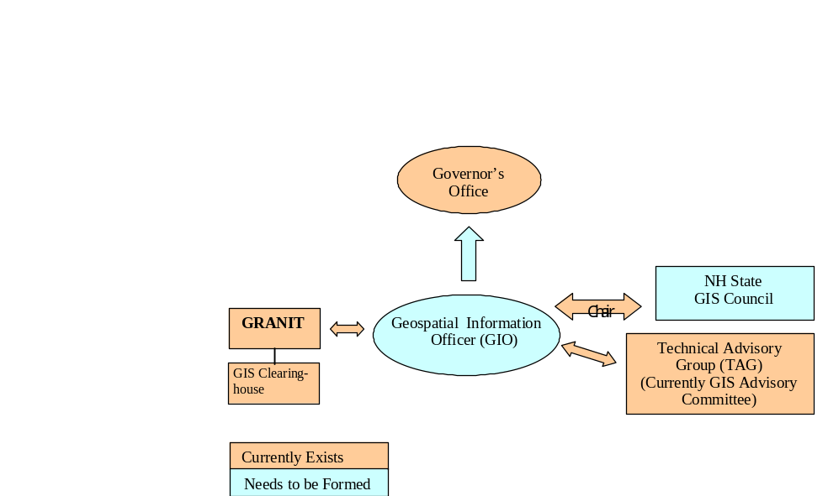The following diagram is a schematic of how GIO oversight and support relationships would look based on the proposed structure.

PROGRAM Costs
While benefits are expected to accrue once a GIO is in place, money must be spent to get to the desired future state of affairs. The support needed for the GIO position is quantified in the table below.

NH GIO Costs | Year 1 | Year 2 | Two Year Total
GIO Salary | $105,000 | $108,675 | $213,675
GIO Benefits | $50,400 | $52,164 | $102,564
Overhead costs (rent to supporting agency, equipment, software licenses, travel, etc.) | $25,000 | $25,875 | $50,875
GIO Costs | $180,400 | $186,714 | $367,114
Cost Factors:
The benefits are calculated based on 48% of salary. | 48%
Salary increase of 3.5% per year (unclassified position). | 3.50%
Increased insurance/benefits costs of 10% per year. | 10.00%

Implementation Plan
This implementation plan calls for a two year plan of activities for establishing a GIO position within the State of New Hampshire and moving ahead on the NH GIS Strategic Plan agenda. Day-to-day responsibilities of the GIO as listed in section 4.1 are a complement to the chart below. The chart depicts activities and milestones over the next two years, for both GSPAC and the proposed GIO. Since the position is proposed to report to the Governor’s Office, a meeting with the Governor’s Budget Director in the near-term is essential to seek endorsement and support for the plan. Also, certain follow-up activities on the part of CORD member agencies are implied by the plan, particularly with regard to securing funding for the GIO position, both initially and long-term. Support from the Governor’s Budget Director and CORD members is essential.

Geospatial Information Officer and GIS Strategic Planning Advisory Committee Two Year Implementation Plan

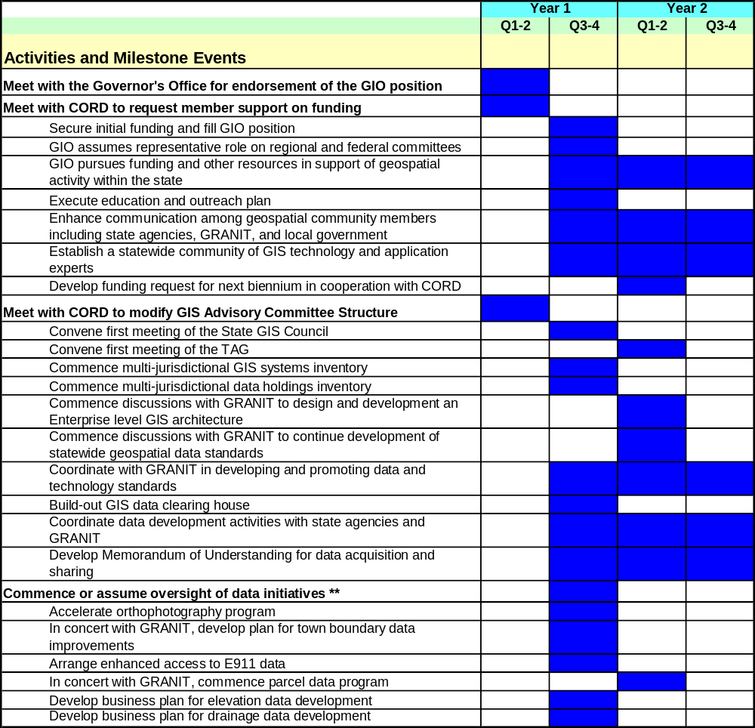

** A number of the data initiatives will have commenced before the GIO position is filled, with the GIO then assuming oversight and management responsibilities.
Milestone events are shown in bold in the chart above.

Programmatic Scorecard
The programmatic scorecard provides a quantitative mechanism for determining what level of progress has been achieved over time. Assessing progress against proposed ‘targets’ provides a ready means to determine the current success level. If necessary, adjustments to the implementation strategy can be made, based on progress.

Below is a preliminary scorecard for the defined programmatic goals. It can be modified and extended as appropriate. On a predefined schedule, it is recommended that the set of tasks be reviewed and the checklist updated to reflect task completion. Totaling the number of checklist points enables a percentage estimate to be made against the target 70 points.

Programmatic Goal
Establish a dedicated Geospatial Information Officer (GIO)
TASKS | Total Points | Current Score | CHECKLIST
Establish GIO position | 6 |  | - Obtain funding approval (2 points)  - Post job (1 point)  - Interview candidates (1 point)  - Fill position (2 points)
Develop comprehensive objectives in cooperation with oversight structure | 15 |  | - Meet with GIS Council (1 point)  - Meet with TAG (1 point)  - Develop short, medium, and long term coordination and planning objectives (1 point)  - Assign priorities and develop oversight and management protocols (1 point)  - Obtain oversight approval (2 point)  - Initiate short-term activities (1 point)  - Initiate medium term activities (1 point)  - Initiate long term activities (1 point)  - Accomplish short term objectives (2 points)  - Accomplish medium term objectives (2 points)  - Accomplish long term objectives (2 points)
Execute outreach program | 6 |  | - Meet with all appropriate agency representatives to develop a state-of-the-state GIS use and needs picture (2 points)  - Develop education and outreach message in collaboration with UNH Cooperative Extension (1 point)  - Deliver education and outreach message (1 point)  - Establish Intranet based website for the sharing of GIS related news and information (2 points)
Complete data holdings inventory | 5 |  | - Meet with all appropriate agency representatives to develop a state-of-the-state GIS data holdings inventory (2 points)  - Assist GRANIT’s responsibility to develop and publish data holding catalog (1 point)  - Update federal GIS data inventories (2 points)
Complete GIS systems inventory | 3 |  | - Meet with all appropriate agency representatives to develop a state-of-the-state GIS systems inventory (2 points)  - Complete systems Inventory report (1 point)
Commence the development of statewide data standards | 8 |  | - Review federal and other state data standards and specifications (1 point)  - Establish strategies, procedures and protocols for the development of NH GIS data standards, e.g., are standards proposed and established through data working groups? How are state agencies to be involved? What are the requirements for compliance? (2 points)  - Identify constituency and assess likelihood of adoption (1 point)  - Prioritize and develop short-term and longer-term objectives (1 point)  - Publish data standards (1 point)  - Establish support mechanisms (resource support, other), that will help agencies adopt the standards (2 points)
Assist with build-out of a GIS data clearinghouse (activities to be carried out by GRANIT) | 6 |  | - Locate hardware and purchase software (2 points)  - Program portal (1 point)  - Load data inventory content and extended metadata (1 point)  - Publish metadata clearinghouse (2 points)
Partner with GRANIT in the development of an Enterprise level GIS architecture (activities to be carried out by GRANIT with GIO involvement) | 6 |  | - Develop RFP for Systems Design (1 point)  - Complete Systems Architecture Design and Implementation Strategy including short and long term requirements and objectives (2 points)  - Develop RFP for Systems Development (1 point)  - Develop Enterprise GIS Architecture (2 points)
Assume oversight of multi-agency data initiatives | 15 |  | - Accelerate Orthophoto program (3 point)  - Implement town boundary data improvements in concert with GRANIT (2 points)  - Provide improved access to E911 data (3 points)  - Commence parcel data program in concert with GRANIT (3 points)  - Develop business plan for elevation data development (2 points)  - Develop business plan for draining data development (2 points)
TOTAL POINTS | 70 | 0

Use the table below to monitor progress towards establishing a performing GIO who is able to support the broader state-level GIS needs in an effective and coordinated manner.

Progress Matrix | Total Points | Dec.  07 | March 08 | June 08 | Sept. 08 | Dec. 08 | March 09 | June 09 | Sept. 09 | Dec.  09
Establish Geospatial Information Officer (GIO) | 70

Use the table below to score overall progress. This will give some indication of the current level of success. Clearly, the successful incorporation of the GIO role into the fabric of the state business operations is a complex and involved activity, which at any point in time will have both successful and less successful aspects. Quantitative metrics need to be accompanied by a narrative description, to ensure a complete and comprehensive report. This report should be provided to the oversight authorities on a regular basis. The table above assumes a quarterly reporting schedule, but can be adjusted to suit the process.

 | Long Way to Go | Needs Improvement | Successful
Total Points | 0-30 | 30-54 | 55-70

Funding Plan
The explicit goal is to obtain state funding for the GIO position. Establishing sustainable funding is one of the 9 Criteria for judging the success of a state’s GIS program. Achieving this will strengthen New Hampshire’s ability to compete for and win grant money as well (e.g., FGDC CAP grants, and DHS Geospatial Preparedness grants). In order to move ahead in the current calendar year, it is requested that CORD member agencies allocate a small portion of their budgets to cooperatively fund the GIO position. Given that there are 12 distinct departments comprising CORD membership, the annual contribution from each could be a modest sum until a specific budget request can be made by the Governor’s Budget Director as part of the next biennium funding cycle.

Education and Outreach Plan
Given the new and the potentially broad reaching impact of the GIO position within the state, it will be important to communicate the benefits, as well as the short and long-term goals and activities to the long established geospatial community in New Hampshire. A full-time GIO will be a ‘change agent’ for the state and will potentially profoundly impact many aspects of the geospatial fabric. It is important that all stakeholders are not only informed of this position and the potential positive impact, but are encouraged to actively support that person to be as effective as possible. Outreach, education, and accessibility, will be an important part of ensuring acceptance of this new role. This new ‘era’ will also offer a new opportunity to establish, and in some cases, reinforce channels of communication between the state and local government.

Conducting outreach about the GIO Initiative and its benefit to improving decision-making at multiple levels is a critical component for success. A concerted effort to inform affected stakeholders about how they can be involved and benefit from this initiative should be expended. The outline below is a high-level summary of an outreach program comprising message development and delivery.

- Message development
- Create substantive messages articulating:
  - Value (e.g., will save time and money)
  - Progress (e.g., will allow better, more cutting edge decisions to be made)
  - Trust (e.g., show understanding and respect for all stakeholders)
- Create talking points for GIO and anyone testifying to the benefits of GIS in improving business processes, e-Government, and decision-making support

- Target audiences definition. There are levels of importance applied to target audiences though each is part of the complete puzzle. The top priority group comprises decision-makers (both those who decide how GIS is used and those who decide what resources to supply to the effort). A second priority group is more focused on external influencers/communicators, such as the media.

Internal Audiences | External Audiences
- Senior level agency managers and decision makers  - Agency GIS users  - Potential and new GIS users  - Council on Resources and Development (CORD) | - NH media  - State agencies  - Town and county administrators, elected officials  - NH legislative leaders  - Other – as the GIO position gets more traction the message can be refined and extended to additional local governments and business leaders

- Collateral development
- Power point presentation with demonstrations, illustrations
- Succinct case studies
- “Leave-behind” brochure highlighting applications in non-technical way

- Communication vehicles
- Media relations: press releases and editorial boards with NH media (newspaper, radio, television).
- Website
- List serves of GIS community, state and federal agencies

- Workshops & Seminars
- Develop whitepaper from case study, use as curriculum basis demonstrating application
- Provide hands-on training at seminars
- Speeches, presentations at board meetings, conferences, and appropriate annual meetings.

- Site visits or GIO-convened meeting with “power users”
- University of New Hampshire
- Department of Transportation
- Department of Environmental Services
- Department of Public Safety
- Others

- Special Events and Partnerships. While the first 12 – 18 months of the GIO’s outreach efforts should emphasize a focus on informing agencies, users and partners about the specific services being offered, there are many exciting possibilities for raising awareness about GIS technology and applications in the future. Options include:
  - Outreach for special projects
  - GIS Day at the Legislature or Governor’s GIS and Mapping Day

NOTE: As the Program is fine-tuned during implementation, the specifics of the Education Strategy should be adjusted to reflect those modifications and the preferences of the GIO.

Appendices

Document History

Version # | Date | Description | Responsible Party
1.0 | 3/7/07 | Contractor First Draft | AppGeo
2.0 | 4/1/07 | Contractor Second Draft | AppGeo
3.0 | 4/11/07 | Contractor Final Draft Deliverable | AppGeo
4.0 | 6/6/07 | Strategic Plan Advisory Committee final | Strategic Plan Advisory Comm.

Potential Geospatial Data Users and Data Gaps

 | Potential Users of Data
Data Gaps | Admin Services | New Hampshire Housing Finance Authority  (NHHFA) | Dept. of Cultural Resources (DCR) | Office of Energy and Planning  (OEP) | Dept.  of Safety (DOS) | Bureau of Emergency Management (BEM) | Dept. of Health  and Human Services (HHS) | Dept. of Environmental Services  (DES) | Dept. of Transportation (DOT) | Dept. of Education  (DOE) | Fish and Game  (F & G) | Dept. of Resource and Economic Development (DRED) | Dept. of Agriculture  (DOA) | Municipalities
Orthophotography | c | c | c | H | H | H | c | H | H | c | H | H | H | H; P
Municipal Boundaries | c | c | c | H | H | H | c | H | H | c | H | H | c | H; P
Detailed Elevation | c | c | c | c | c | H | c | H | H | c | c | c | c | H; P
Parcels | H | H | H | H | H | H | H | H | H | H | H | H | H | H; P
Drainage Network |  | c | c | H | c | H | c | H; P | H | c | H | H | H | H; P
Street Centerlines | c | c | c | H | H; P | H | c | H | H; P | H | c | H | c | H; P
Addresses | H | H | H | H | H; P | H | H | H | H | H | c | H | H | H; P

(c = casual consumer; H = heavy consumer; P = producer)

