The New Hampshire LiDAR collection is maintained in an Esri Mosaic Dataset comprising individual LiDAR footprints that have been acquired over the past several years. These footprints correspond to individual projects that vary in their collection and processing specifications, which makes the Mosaic Dataset an ideal format in which to store and deliver the data. The Mosaic Dataset includes a statewide bare earth Digital Elevation Model (DEM) produced by GRANIT staff, representing a compilation of individual DEM tiles and configured to deliver standardized data with respect to projection and horizontal/vertical units upon data extraction. The statewide bare earth DEM is used as the input layer to the geoprocessing steps described below.
GRANIT staff will create 2-foot contours for each HUC 10 watershed in the state. The following workflow is proposed:
- Select a HUC 10 watershed.
- Buffer selected HUC 10 watershed by 1500 meters.
- Subset the statewide bare earth DEM to the extent of the selected HUC 10 watershed.
- Clip the newly created DEM subset to match the buffered HUC 10 watershed boundary using Extract by Mask. (Note: The Extract by Mask tool does not work on the statewide DEM, requiring the intermediate step listed above.)
- Smooth the clipped DEM using Focal Statistics with a circular, 6 pixel neighborhood.
- Contour the smoothed DEM using an interval of 2 and a Z-factor of 3.2808 (to convert DEM vertical units to feet).
- Clip the resulting contours using the unbuffered HUC 10 watershed boundary.
- Break the contour lines using the ArcGIS Dice tool with a maximum vertex count of 5000 to improve draw performance. (Although this will increase the number of features, it does not appreciably change the file size when exported to a shapefile.)
- Add/populate an Index field to identify 10 and 100-foot contours.

The suggested Workflow Model uses an iterator to cycle the HUC 10 watersheds and run a set of geoprocessing tools to subset the DEM to a specified area of interest, smooth the subsetted DEM, produce the output contours, and perform a few finalizations tasks. The figure below shows the iterator and subsetting process.
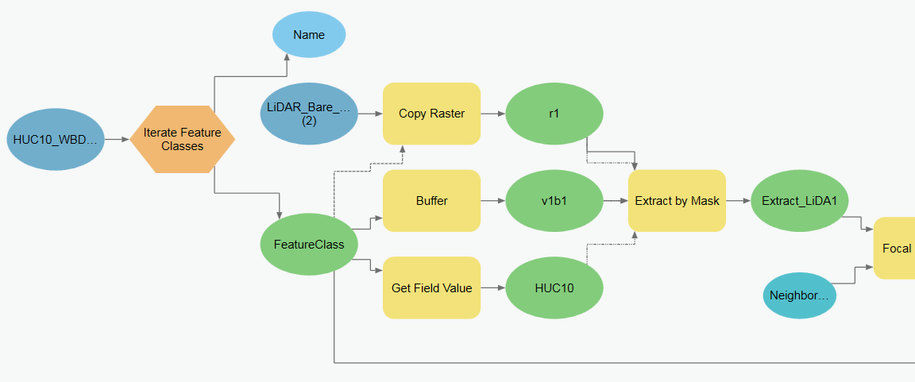

The next figure displays the smoothing, contouring, clipping, and dicing tools.
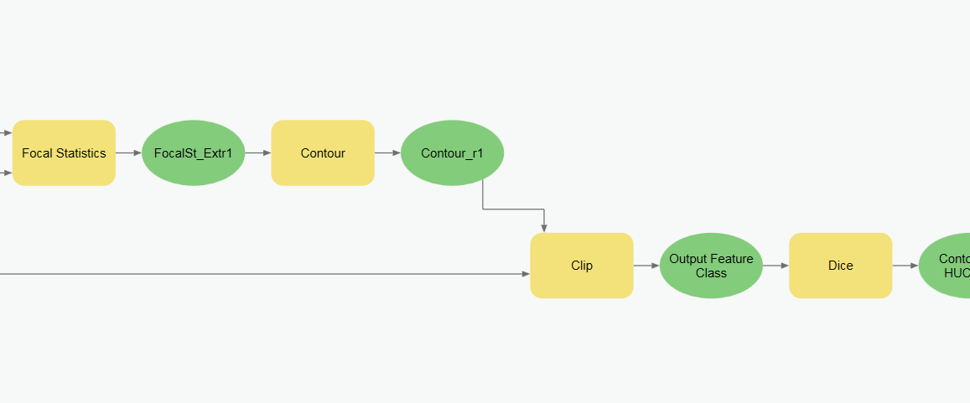

This figure shows the finalization steps which include adding and calculating the index fields.
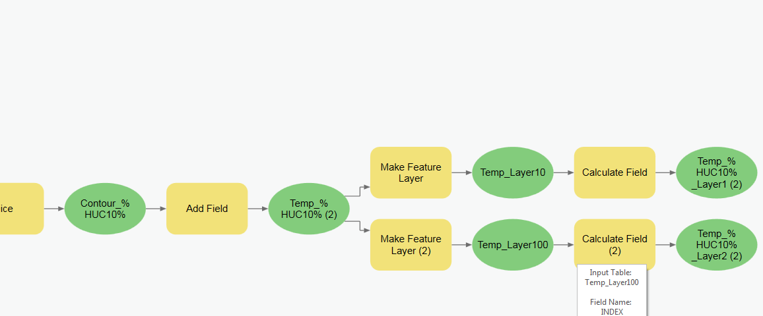

Example 2-foot contours (scale 1:1,000) generated by the Workflow Model for a small area near Keene, NH are shown in the figure below. This illustrates the quality of the output contours, including the level of edgematching, that can be expected by the Workflow Model.
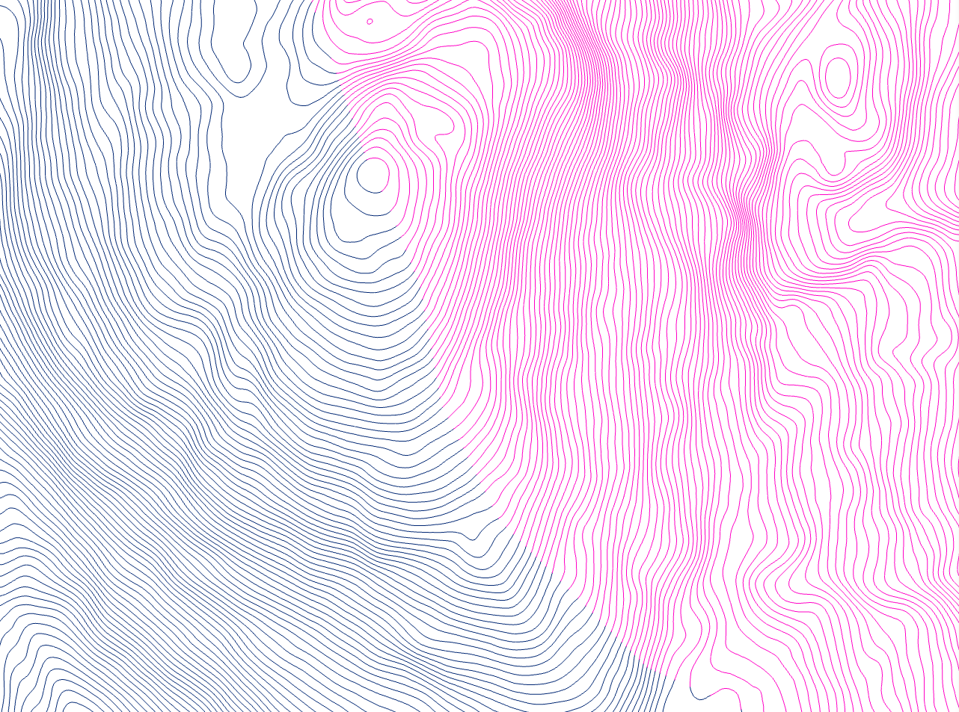

The figure below presents a close-up view of the contour edgematching at the watershed boundary (scale 1:1).
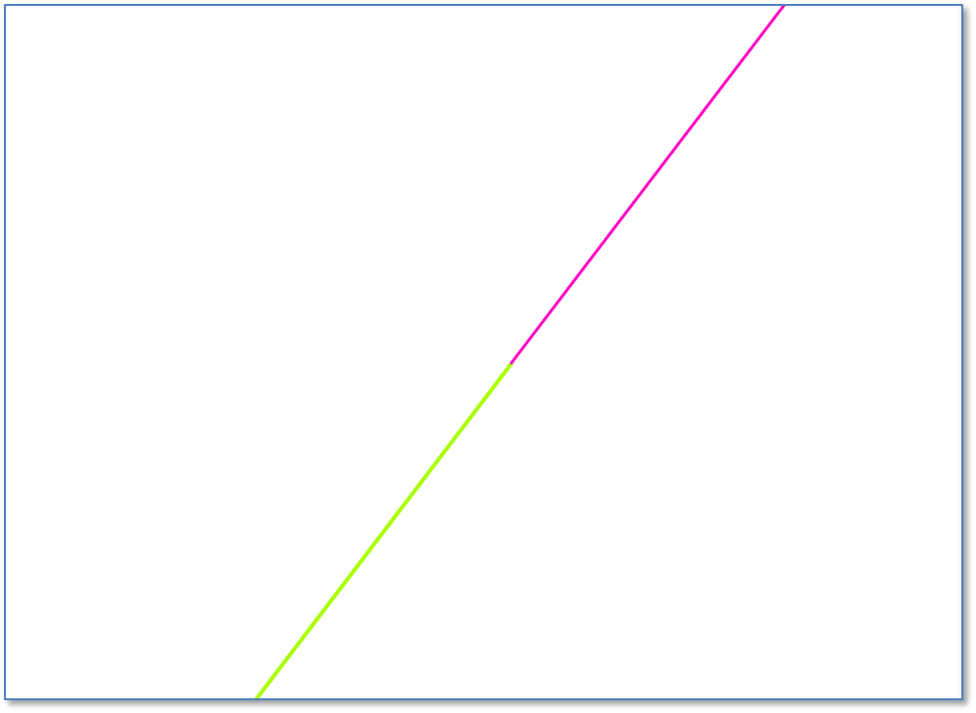

Finally, the figure below demonstrates the effect of the suggested Focal Statistics Neighborhood radius. Note that Focal Statistics using the 6 pixel neighborhood produces more generalized, smoother contours than does the 3 pixel neighborhood and eliminates the need for post-generation smoothing. Also, notice the reduced number of extraneous contours in the wetland area.
