Indicator: Impervious Surfaces

Question

How much of the Piscataqua Region watershed is currently covered by impervious surfaces and how has it changed over time?

Short Answer

In 2015, 5.6% of the land area of the Piscataqua Region watershed was covered by impervious surfaces. This is an increase of 1,257 acres of impervious cover or 0.2% of the land area since 2010.

PREP Goal

No increase in the number of watersheds and towns with greater than 10% impervious cover and no decrease in the number of watersheds and towns with less than 5% impervious cover (from the PREP Comprehensive Conservation and Management Plan, PREP 2010).

Figure IS-1. Percent impervious cover by subwatershed (HUC-12) as of 2015.
Data Source: UNH Earth Systems Research Center.

Why This Matters

Impervious surfaces are man-made features, such as parking lots, roads, and buildings, that do not allow precipitation to infiltrate into the ground. When precipitation falls on impervious surfaces, it runs off those surfaces carrying pollutants and sediments into nearby waterways. Watersheds reach a tipping point around 10% impervious cover (Mallin et al. 2000), beyond which water quality impacts become increasingly severe.

Figure IS-2. Percent impervious cover by town as of 2015. Data Source: UNH
Earth Systems Research Center.

Results Summary (from State of Our Estuaries Report)

The 2015 update to this dataset represents a new, improved baseline for impervious surface estimates across the region due to the use of higher resolution source imagery and different processing methodology. Impervious surface values listed in the 2013 State of Our Estuaries report using 30-meter satellite imagery (63,214 acres) were greater than those listed using 1-foot orthoimagery (45,377 acres) in this report. In 2015, 46,634 acres (5.6% of the land area) of impervious surface were mapped representing an increase of 1,257 acres (0.2% of the land area) since 2010 (45,377 acres). Watersheds with greater than 10% impervious surface coverage of land area are around the Hampton-Seabrook estuary, the Piscataqua River and the Route 16 corridor along the Cocheco River. Impervious surfaces in 2015 in each of the Piscataqua Region subwatersheds are shown as a percentage of land area in Figure IS-1.

Communities with the highest reported impervious surface percentages included Portsmouth (26.7%), New Castle (20%), and Seabrook (20%), while the largest increase of impervious surfaces between 2010 and 2015 occurred in Rochester (122 acres), Wells (64 acres), Seabrook (64 acres), Dover (56 acres), York (42 acres), and Sanford (39 acres). Communities with the smallest increases in impervious surfaces included Madbury (4 acres), New Castle (2 acres), and Brookfield (2 acres). Small increases in impervious surfaces may be a result of limited availability of buildable lots. Town-by-town information on impervious surfaces in 2015 is shown in Figure IS-2.

Between 2010 and 2015 population in the Piscataqua Region watershed increased 6% (21,760 people), and impervious surfaces increased 2.7% (1,257 acres). For every one person increase in population, impervious surface increased by 17 acres. However, as shown in Figures IS-1 and IS-2, the amount of impervious cover is not evenly spread across the watershed. For more discussion on population and housing trends in the watershed, refer to the Housing Permits indicator section of the 2017 PREP Technical Report (PREP 2017).

Methods and Data Sources
A more comprehensive description of methods can be found in Justice and Rubin (2017).

Data sets for the 52-town PREP footprint (see Figure IS-2) were assembled from the NH GRANIT Clearinghouse (granit.unh.edu) and the Maine Office of GIS (maine.gov/megis). The updated IC coverage was derived by displaying the 2010 IC data sets for the project area over
the 2015 source imagery, and manually digitizing new IC features visible in the imagery. Data were initially displayed at a minimum scale of 1:2,000 to identify features to be digitized. The scale was typically increased to 1:1,000 (or greater) when actively digitizing features.

In addition to mapping 2015 features, updates were made to the 2010 features to capture or delete IC as appropriate. Most of the updates addressed prior errors of omission (i.e., missing features). Typically, these errors occurred because features on the ground were at least partially obscured by tree canopy in the 2010 imagery but became visible in the 2015 imagery. The errors were addressed by confirming their presence in the 2010 imagery, and then digitizing the features from the 2015 imagery. Errors of commission (i.e., adding features not actually present) from the 2010 data, e.g. false positives, were also updated as appropriate.

After a comprehensive review of the data, the IC polygons were processed to derive the final data set for distribution. First, the vector polygons were converted to a 1-foot resolution raster. To fill any small gaps between features, the raster data set was expanded by 2 pixels and then contracted back by 2 pixels. Lastly, the raster was converted back to vector format, the IC polygons were generalized (using a maximum offset of 2 feet), and small features (less than 20 sq. ft.) were eliminated.

Data Sources
The data source for this indicator was geographic data layers of impervious surfaces in the Piscataqua Region watershed produced by the UNH Earth Systems Research Center. The data are available for download from NH GRANIT. The primary source data for the project comprised 2015 1-foot resolution, 4-band orthophotography in New Hampshire; 2015 1-meter resolution, 3-band orthophotography in Maine; and existing 2010 impervious cover (IC) feature data sets. Older vintage orthophotography (2010 and 2005) was also used for reference.

Additional Results (Beyond the Data Reported in the SOOE)
The primary result of this project is a high resolution (HR) impervious cover data set capturing features for the year 2015 within the 52 town PREP footprint. Figure IS-3 displays the distribution of impervious cover mapped throughout the study area. Figure IS-4 graphically shows impervious cover by town. Tables LS-1 and LS-2 summarize the impervious cover by town and subwatershed.

PREP goals were earlier stated as: “No increase in the number of watersheds and towns with greater than 10% impervious cover and no decrease in the number of watersheds and towns with less than 5% impervious cover.” One additional municipality (Rochester, at 10.1% impervious cover) has been added to the list of towns with impervious cover over 10% (Table LS-1). One sub-watershed (Taylor River, at 10.3%) has been added to the list of sub-watersheds with impervious cover over 10% (Table LS-2).

There was no decrease in the number of towns with impervious cover less than 5% (Table LS-1). However, there was a decrease in the number of sub-watersheds less than 5% impervious; the BaunegBeg Pond/Great Works River sub-watershed went from 4.9% in 2010 to 5.0% in 2015 (Table LS-2).

Of the 52 towns, 48 saw slight increases (e.g., 1 – 2%) in impervious cover; four municipalities stayed the same. Of the 40 sub-watersheds, 33 saw slight increases in impervious cover; seven sub-watersheds remained at 2010 levels.

There were no decreases in impervious cover for any town or sub-watershed.

References Cited

Justice, David and Rubin, Fay, "Developing 2015 High-Resolution Impervious Cover Estimates for the 52 Towns in the Piscataqua Region Estuaries Partnership: Final Report" (2017). PREP Publications. 395.
http://scholars.unh.edu/prep/395

Mallin, MA, Williams, KE, Esham EC, Lowe, RP. 2000. Effect of Human Development on Bacteriological Water Quality in Coastal Watersheds. Ecological Applications, Vol. 10, No. 4 (Aug., 2000), pp. 1047-1056
Published by: Wiley on behalf of the Ecological Society. Stable URL: http://www.jstor.org/stable/2641016.

PREP 2010. Piscataqua Region Comprehensive Conservation and Management Plan, Piscataqua Region Estuaries Partnership: D.B.Truslow Associates, Mettee Planning Consultants, 2010, Durham, NH. http://scholars.unh.edu/prep/22/. Accessed 14 September 2017.

PLACEHOLDER FOR DATA REPORT REFERENCE. (SEE PREVIOUS COMMENT)

To Add, Time Allowing

- Look for critical points from TAC feedback.

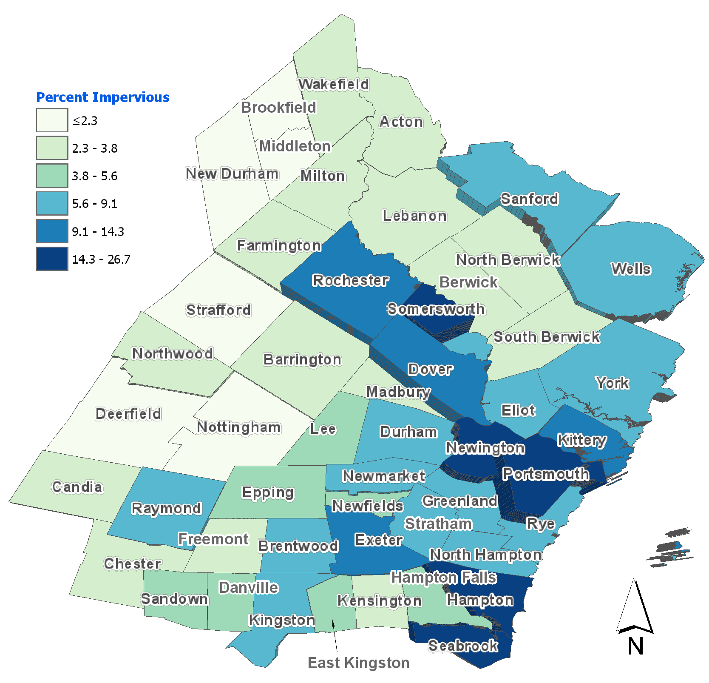

Figure LS-4. Percent impervious cover by town, 2015.

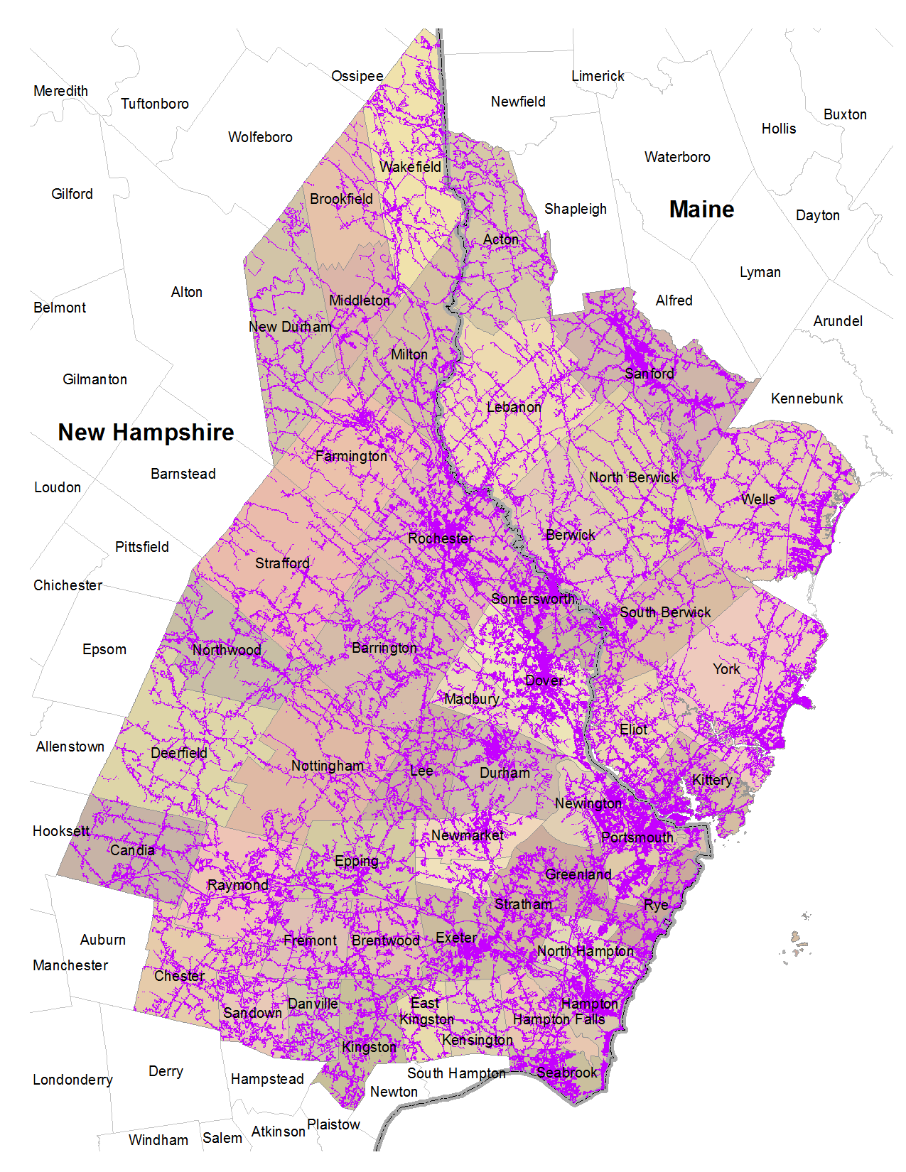

Figure LS-3. Distribution of 2015 impervious cover in the project study area. Impervious features displayed in purple.

